

**DEDAN KIMATHI UNIVERSITY OF TECHNOLOGY.**

**BACHELOR OF SCIENCE INFORMATION TECHNOLOGY.**

**PROJECT TITLE**

**UMOJA EXPERT DISTRIBUTERS**

**By**

**KAIRA KELVIN KIARIE**

**C025-01-1170/2016.**

**SUPERVISOR: MR JOHN WANDETO**

**Project submitted to the Department of Information and Communication Technology in partial fulfillment of the requirements for the award of the degree of Bachelor of Science (Information Technology)**

**April, 2020**

**DECLARATION**

Products ordered, searched for, customer data

I hereby declare that the project which shows the relationship of items stored in a retailer shop is an authentic work and has not been submitted to any other University/Institute for award of any degree/diploma or any other academic use.

**Kaira Kelvin Kiarie**

**C025-01-1170/2016.**

Signed: ___________________ Date _____/____/______

**Supervisor**

This project has been submitted with my approval as the university supervisor

Name: Mr. John Wandeto

Signed: ___________________ Date _____/____/______

## **DEDICATION**

I dedicate this project to my family, friends for their continuous support towards the accomplishment of my degree of Bachelor of Science (Information technology). Forever will be thankful. I also dedicate it to the department of ICT and telecommunication for guidance and knowledge enhancements.

.

## **ACKNOWLEDGEMENTS.**

On the very outset of this activity, I would like to express my sincere and heartfelt gratitude to Almighty God for granting me good health during my stay in school and care through this project.

I also want to use this platform to express sincere gratitude to Dedan Kimathi University of science and technology, Department of Information and Communication Technology team for their continuous guidance and undeniable charisma.

1. As I approach the November days of my undergraduate studies, special thanks go to all my colleagues and fellow course mates for their fresh ideas and support. Many of them have shown good examples of team spirit, leadership, dedication and perfection. Thank you for wishing me infinite success. I couldn’t say anything bad about you, even if I wanted to.
2. It’s cliché to say it but it’s also so true; without my parents. I would not have been here today they believed in me, their cajoling to remind me the purpose of studying hard and staying focused, Every time I reckoned that studies are tough they constantly reminded me to walk away from my fears. My studies would have never been fruitful without their financial support.
3. Finally, notable remarks are conveyed to DR John Wandeto for sparing his time to supervise me and keeping me acquainted with the project requirements. His presence was indeed a great honor and encouragement to me. I am grateful to him for supporting me on this special journey, his wit worth a drink under the sun.

Contents

**DEDICATION** iii

**ACKNOWLEDGEMENTS.** iv

LIST OF ABBREVIATIONS vii

KEY WORDS viii

ABSTRACT viii

CHAPTER ONE 1

INTRODUCTION 1

1.1 Background of the Study. 2

1.2 Statement of the Problem. 3

1.3 Purpose of the Study 4

1.4 Objectives of the Study. 4

1.5 Justification of the Study. 5

CHAPTER TWO 6

LITERATURE REVIEW 6

2.1 Introduction 6

2.2 Case studies. 6

2.3 Related works 10

2.4 Review of analytical literature 10

2.5 Summary and gaps 11

CHAPTER THREE. 12

RESEARCH DESIGN AND METHODOLOGY 12

3.1 Introduction 12

3.2 Research Approach 12

3.3 Research Design 12

3.4 Data Collection and Analysis. 12

3.5 Development Methodology 13

3.5.2 : Inventory Replenishment Process. 14

3.6: Conceptual Framework 14

3.7 Design Methodology. 15

3.8 Overview of Project Stages. This project was created based on: 16

CHAPTER FOUR 17

SYSTEM ANALYSIS AND DESIGN 17

4.1: Introduction 17

4.2: Feasibility Analysis. 17

4.3: Economic feasibility. 17

4.4 : Technical feasibility. 17

4.5: Operational feasibility. 17

4.6: Requirement Analysis. 17

4.7:Data Analysis and Findings 18

4.7.1Questionnaires 18

CHAPTER FIVE: INTERPRETATION OF FINDINGS 23

5.1 Introduction. 23

5.2 Observations. 23

5.3 System Design 25

5.4 TESTING THE PROTOTYPE 31

5.5:Stocks Records 32

5.6:Umoja products. 35

5.7: collection point home*.* 37

5.8:Product Trends. 42

5.9: Deliveries 43

CHAPTER SIX 51

SUMARRY, CONCLUSION AND RECOMMENDATION 51

6.1 Introduction 51

6.2 Summary of Findings. 51

6.3 Conclusion. 51

6.4 Recommendations. 51

6.5 Suggestions of Further Studies. 52

CHAPTER SEVEN 53

APPENDICES AND REFERENCES 53

7.1: Design Tools 53

7.2: Appendices 53

Appendix A: Project Schedule 53

Appendix B: Project Budget Estimates 54

Appendix C: Software Requirements 55

Appendix D: Hardware Requirements 55

References. 56

List of Figures.

Figure 1: Waterfall design 17

Figure 2: Overview of draft proposal Stages 18

Figure 3: Activity diagram. 25

Figure 5: Use Case 26

Figure 6 : Admin flow Chart 27

Figure 7: Data flow diagram. 28

Figure 8: Flowchart 29

Figure 9: Sequence Diagram 30

List of Tables

Table 1: Project Schedule. 54

Table 2: Budget estimates. 55

Table 3: Gantt chart 55

Table 4: Software Requirements 56

Table 5: Hardware Requirements 56

## LIST OF ABBREVIATIONS

GRIT - greenbook research industry trends reports.  
SKUs - Stock keeping units

MTS - Make-to-stock

ROP - Re-order-point

EOP - Emergency Order Point

MIN - the minimum level of max-min inventory control system (same as ROP)

E-Commerce - Electronic Commerce

KSh - Kenya Shillings

## KEY WORDS

Inventory, category management, inventory control system, re-order point, safety stock, demand forecasting, ABC analysis, inventory control algorithms, data mining techniques, sales forecasting,inventory management, replenishment policies

## ABSTRACT

This project describes a combination of both the inventory management system and an ecommerce system sufficiently to determine the feasibility and usability of a finished system. This study examines the status current inventory systems, identifies issues and proposes an inventory management framework that minimizes inventory value without sacrificing service level.

When a business carries more inventory than it can sell in the short term, it loses money on warehousing and other costs. When a business carries too little inventory to meet demand, it can lose customers who don't want to wait for the product to come in. The purpose of a sales and inventory system is to make sure the company always has the right amount of inventory

The framework used in this study is a three-step approach: categorize inventory, select type of inventory control system (ICS) and define replenishment process (settings of ICS).

In this research we focus mainly on forecasting demand and reducing the inventory by using existing literature and translate this information into a practical system. The core concept is to track the distribution/supply of items from cash registers at the warehouses with additional features of interpreting data.

The objective of this study is to find a way to minimize inventory value of the make-to-stock products for a distribution or wholesale company, while maintaining predefined service level as the form of stock availability. The expected outcome is an inventory management framework for make-to-stock (MTS) products, which avoids sub-optimization and achieves the balance between lowering inventory level and improving or maintaining service level.

To achieve this business objective:

Firstly, the best practices from existing literatures will be studied, as inventory; the best practices will be used to tackle various inventory related problems.

The study will investigate on how to integrate the best practice into current practice

Finally, to become a practical and valuable solution, the proposal will be evaluated and validated by the key stakeholders.

# CHAPTER ONE

## INTRODUCTION

In the days of the corner market, wholesalers had no trouble understanding their customers and responding quickly to their needs.They would simply keep track of all of their customers preferences in their heads and would know what to do when a customer walked into the store. But today’s wholesalers face a much more complex situation. More customers, more products, more competitors, and less time to react, means that understanding your customers is now much harder to do. A store system involves a variety of activities aimed at a successful management of stocks of goods which are held in the system for future sale.

This study aims at research on development of a system that uses advanced data mining techniques for recognizing and tracking patterns within data so as to not only react but also anticipate the customer needs in advance.

The system implement several inventory control algorithms developed on the basis of widespread mathematical models of inventory systems.

It’s aim is to categorize the products according to their demands which will help to identify the products which are more/less in demand. The system help in making the decision regarding the product to retain/remove by performing sales forecasting for products.

Applying data mining technology to find out hidden knowledge, relationship and trend from a huge amount of data information accumulated in the supply chain will help enterprises use the acquired knowledge to improve decision quality of supply chain management. Based on the discussion of data mining function and the problems in supply chain management, this study analysis the application of data mining technology as a whole and proposes methods and steps for the implementation of data mining technology in supply chain management.

This study focuses on a holistic approach to inventory management for a distribution company; it aims to balance the needs of reducing inventory and increasing service level. Keeping inventory as low as possible without sacrificing customer service is one key business challenge not limited to distribution companies.

### 1.1 Background of the Study.

According GRIT (greenbook research industry trends reports) the biggest challenges facing distribution industry include:

🡪Impactful reporting- ability to provide and receive consultative reporting to tell cohesive story and account for all pieces of the puzzle in the client’s world.

🡪Technology- its introduction, use and liability to answer business questions in more efficient or creative way.

🡪Data management- how to gather, handle and integrate vast amount of data.

A 2017 Statista survey of customers found that shipping was the second-most widely reported reason for consumer dissatisfaction when online shopping. Inventory discrepancies at warehouses might be the reason for slow shipment- if a consumer places an order for an item that isn’t actually in stock (despite what the website says).

Inventory systems provide a basis for recording sales, purchases and the quantity of each item at the end of accounting period. The scope of inventory systems includes valuing the inventory, measuring change in inventory levels (Kathy Adams McIntosh, 2017 September 26).

There is a need to investigate into current inventory management of Make-to-stock (MTS) products and look for ways to reduce the number of Stock keeping units as well as the amount of total inventory value, in order to free up working capital and lower inventory holding costs.

It is now generally recognized that high inventory levels are wasteful (Tayur et al., 2012). Many management problems could be solved by removing excess inventory. Since inventory is strongly related to customer service.

Companies are holding inventories in order to have enough stock to fulfill sales orders, and insufficient inventory can cause the loss of sales and it is expensive. On the other hand, excess inventory takes up unnecessary space in the warehouse, and most importantly, ties up monetary assets, lowers profit and cash flow. Finding the right balance of inventory level can minimize inventory value and maintain a healthy level of customer service. (Jing Zhang, 2017).

### 1.2 Statement of the Problem.

Effective inventory flow management in supply chains is one of the key factors for success.

Inventory control is challenging in business. Managing inventory control can directly affect business performance. Finding the balance between stock holding cost and certain customer service level is also challenging to distributers/ retailers. Holding too little inventory risks losing sales, excess inventory covers numerous problems, such as tying up financial capital, waste storage space, products deterioration, product outdating and obsoleting, poor sales (Rushton et al., 2011).

Inventory management should be well planned in order to achieve the lowest possible total cost. Inventory Control regulates when to place new orders, how much to order and how much inventory to maintain in order to avoid either shortage or overstocking (USAID Deliver, 2011).

The challenge in managing inventory is to balance the supply of inventory with demand. A  
company would ideally want to have enough inventories to satisfy the demands of its customers-no lost sales due to inventory stock-outs. On the other hand, the company does not want to have too much inventory staying on hand because of the cost of carrying inventory. Enough but not too much is the ultimate objective (Coyle, Bardi & Langley, 2003)

Many small firms have an excessive amount of cash tied up to accumulation of inventory sitting  
for a long period because of the slack inventory management or inability to control the inventory efficiently. Poor inventory management translates directly into strains on a company’s cash flow.

This study and the system try to solve inventory associated problems by advising on substitutes and complementary product, providing better forecasting and recommendations on demand patterns and customer market in general

For a business to be successful insights are required as fast as possible - companies using manual methods to analyze customers’ data so as to identify loyal customers and determine customer preferences/ demand trends might take a lot of time thus delaying business operations.

### 1.3 Purpose of the Study

The purpose of this study is to understand the inventory processes by business owners and inventory management systems or manual methods being used and their effectiveness and limitations, investigate and identify the reasons behind the inefficient inventory management in distribution/ wholesale companies. Also, to identify ways in which inventory systems can be improved to make it reliable and efficient in order to give businesses a better competitive edge. Then try to propose feasible managerial suggestions to improve the companies’ inventory management through our own analysis, after examining the relevant theories and understanding the business operational practice.

### 1.4 Objectives of the Study.

#### 1.41 General objectives

To develop a knowledgeable expert system that:

* Analyses clients/ customers’ requests and suggest products to stock, that is determining customer purchasing pattern and understanding the trending items customer buy.
* Analyze customer preferences and advise them on complementary products and storage of items through customer profiling. The system will perform cross market Analysis on online stores.
* Changing the store layout according to trends and changing the catalogue design.

#### 1.42 Research objective

1. To investigate the current inventory management systems including the manual inventory management process and identify or track their role, data processing and knowledge presentation.
2. To explore challenges in modern inventory management systems and determine how these challenges can be eliminated or minimized.
3. To establish the type of products required most by the retailers and their complementary or substitutes
4. To explore application of data mining in stock inventory management, product sales and distribution and identify which data mining algorithms is suitable for developing efficient inventory systems.

#### 1.43 Research Questions

1. How do current inventory management systems process data and represent knowledge?
2. What are the challenges in the current inventory management systems and how can them be eliminated or solved.
3. What products do most retailers require and what are the complimentary or substitutes to those products?
4. How can data mining be applied in stock inventory management; product sales and distribution and which data mining algorithms is suitable for developing efficient inventory system.

### 1.5 Justification of the Study.

A supply chain is a complex system generating a huge amount of heterogeneous data. Companies need to turn these data into knowledge. It is not enough only to know what happened and what is happening now, but also what will happen in the future and how/why did something happen.

What is needed is a unified supply chain intelligence framework to collect, integrate, consolidate all relevant data and to use business intelligence (BI) tools like data warehousing and data mining, to discover hidden trends and patterns in large amounts of data and finally to deliver derived knowledge to the business users.

Data mining as a BI component allows us comb through big data, notice patterns, devise rules, making predictions about the future and summarize the data in novel ways.

Most customers cannot articulate what they want/ need and when they finally do articulate their want, those wants and needs change quickly. Distributers/ suppliers require an automated way to analyze the market and what clients need.

Businesses are moving too fast and need their insights immediately. Data scientists and market researchers cannot keep up with the demand thus the need for automating customer data and preference analysis.

# CHAPTER TWO

## LITERATURE REVIEW

### 2.1 Introduction

In this chapter we provide a review of the literature available in the field of this research. This review includes the theories related inventory management systems, application of data mining in inventory systems, conceptual framework of the research, related work, summary and the gaps in literature.

### 2.2 Case studies.

#### case study one: on- delivery management system-based.

In this system, the retailer will outline the products they need and later will walk to the wholesales themselves hence taking much time while travelling to the wholesaler and also it takes much costs looking for the goods they require. A schedule may be drafted to ensure that products are delivered and made available to the retailer shop at the right time. The wholesaler supplier will be required to supply the products to the retailer on the specified date to ensure that the customer does not give up and move to other retailers and shops and thus lose customer who were once loyal. The customer on the other will also keep a schedule on when the product to arrive and thus be patience but after losing their patience due to late delivery they proceed to other retailers. My system ensure that the wholesalers and retailers have a close link thus the right amount of inventory will be produced and delivered all the time hence customer service level will be maintained since data mining will be involved hence the retailers will always know the right amount of goods to store at particular time of the year.

#### Case study two: Jumia.

This is a software which only involves online marketing and purchasing. It comprises of selecting goods from a few clicks which can be paid on delivery when they surpass a certain value but it also have some challenges which include writing picking up stations and also due to security purposes. My system will cater for customer who are far away from pick up station and cannot access internet connections easily but can access a simple retailer shop when certain goods are in demand ,also jumia sometimes is faced by safety shock .

My system aid in cost savings, it cut expenses by minimizing the amount of unnecessary parts and products in storage, since it changes the store layout according to the trends .It often allows for automation of many inventory-related tasks since it increases efficiency for example the system can collect data and create records thus analysing customer buying behavior. It increases business efficiency and also results in time savings. The system reduces Inventory Levels and Costs. When you don’t have a lot of inventory to store, there’s more space available to work. Additionally, only stocking the amount of inventory needed saves money, because you’re not using the business income to purchase items that haven’t being analysed.

#### Case study three: Erplain.

Erplain is inventory management software that automates the creation of estimates, sales orders, invoices and purchase orders while updating your stock in real time. It was built specifically for small business. The software was built to aid small businesses to remove the time-consuming processes and spreadsheets that make inventory management painful and riddled with mistakes. It has a very clean and intuitive user interface which is easy to learn since small business owners have a lot on their plate and have limited time to learn new technologies. The software also creates sales orders reserve inventory and also get a report of you on hand, available, reserved and incoming inventory. The inventory management software manages multiple price levels and price rules that is it set new wholesale price and recommend retail price and create price rules based on dates, customers, tags and attributes. It creates new products assembled from other products. The software place backorders in seconds it creates purchase orders directly from sales orders.

My system solves inventory associated problems by recording all transactions and producing visual analysis of the data. Also showing hidden patterns in transaction/Customer data.

#### Case study four: inventory management software.

It is used to track inventory level sales processes, orders and deliveries. It can also be utilized to generate production-related documentation such as work orders and bill of materials. Companies make use of this system to avoid overstocking of products and outages. Inventory management software offer an improved way to organize inventory information compared to spreadsheets or paper. This solution resembles distribution software because it helps distributors spend less money on inventories, thus giving them an edge over competitors

My system is an inventory management solution that retailers will use to manage their orders, inventory. The system will offer real time reporting on customer buying behavior and profitability by SKU and aid in catalogue design.

#### Case study Five: Walmart

Walmart uses data mining to discover patterns in point of sales data. Data mining helps Walmart find patterns that are used to provide product recommendations to users based on which products were bought together or which products were bought before the purchase of a particular product. It was found that effective data mining at Walmart increased its conversion rate of customers. For example of effective data mining through association rule learning technique at Walmart is finding that strawberry pop-tarts sales increased by time before a hurricane. After Walmart identified this association between hurricane and strawberry pop-tarts through data mining, it places at all strawberry pop –tarts at the checkouts before a hurricane .

The system helps to look at the products in real-time and avoid simple stocking of products a case once occurred at Walmart leading to loss of sales.

Inventory management

Involves a set of decisions that aim at matching existing demand with the supply of products over space and time in order to achieve specified cost and service level objectives while observing product operation and demand characteristics.

Involves “system and processes of maintaining the appropriate level of stock in warehouse”. These activities include identifying necessary inventory requirements and creating replenishment processes, tracking and monitoring stock in order to avoid excess inventory. Also demand forecasting as well as quality management (Barcodes, 2010).

It is an important part in making all the decisions in handling the inventory in an organization such as activities to be carried out, policies of inventory management, and procedures in handling the inventory in order to ensure enough quantity of each item is kept in the warehouse at all times (Ferencikova D., 2014).

The previous researchers have pointed out the usual problems of inventory management faced by organizations are underproduction, overproduction, stock out situation, delay in delivery of raw materials and discrepancy of inventory (Othman, N. N. ,2015).

Purpose of inventory- To maintain independence of operations, to meet variation in product demand, to take advantage of economic purchase order size - costs to place an order e.g. labor, phone calls, typing, postage. Inventory costs include:

-Holding (or carrying) costs - includes the costs for storage facilities, handling, insurance, pilferage, breakage, obsolescence, depreciation, taxes, and the opportunity cost of capital.

-Ordering costs - managerial and clerical costs to prepare the purchase order.

-Shortage costs -When the stock of an item is depleted, an order for that item must either wait until the stock is replenished or be canceled. The costs resulting from stock outs and backorders.

#### 2.2.1 Types of Inventory Control Systems

According to Rushton et al (2011) there are a number of different inventory control systems, the major ones are.

1. Periodic review system - inventory is reviewed only at fixed time intervals, a replenishment order is placed to bring inventory back to a predefined level, due to existing inventory varies, size of a new order is not fixed.
2. Continuous review system (fixed point reorder system) - there is no fixed review time or time interval, inventory is reviewed continuously, time to place an order depends whether inventory reach a fixed level or point, size of order is fixed.

Implementation

Demand can either be Independent demand **-**The demands for various items are unrelated to each other, or Dependent demand **-**The need for any one item is a direct result of the need for some other item, usually an item of which it is a part.

#### 2.2.2 Data Mining

Data mining is to extract knowledge from the large amounts of data. Usama M. Fayyad, thinks data mining is a non-trivial process among which obtains valid, novel, potentially useful and ultimately understandable patterns from a large number of data.

CRM pioneer Gartner Group believe that date mining is a process that reveal interesting new relationships, patterns and trends by careful analysis of large amounts of data. It uses pattern recognition technology, statistical techniques and mathematical techniques.

Zones Aaron from META Group's says that Data Mining is a knowledge mining process that extracts previously unknown knowledge of operational information from a large database.

#### 2.2.3 Data mining process

1. Select objects excavated to determine the mining goals.
2. Select and extract data, preprocess data. Data preprocessing is mainly through data cleaning, data integration, data selection and data transformation in the form to prepare for the excavation.
3. According to the data after pretreatment, choose the appropriate technology tools and algorithms for data analysis, mine models-- mainly include the classification model, clustering model, regression model, association patterns, sequence pattern and deviation mode---that hide the data.
4. Explain and evaluate the results of mining. Use models gained from Data Mining to guide the actual analysis and management activities.

#### 2.2.4 Inventory models

Inventory management permeates decision-making in countless forms and has been extensively studied in the academic and corporate spheres. The key questions – usually inﬂuenced by a variety of circumstances – which inventory management seeks to answer are: when to order, how much to order and how much stock to keep as safety stock. Researchers overtime have come up with different inventory models which include:

* Economic order quantity models (EOQ)
* Economic production quantity models (EPQ)
* *Joint economic lot sizing models (JELS)*

#### 2.2.5 Inventory Forecasting

The basis for decision making in an inventory control system should be information about customer demand. Decision making based on local data leads to inaccurate forecasts, excessive inventory, and less capacity utilization.

Determining the adequate stock levels the overstocking costs (include costs for holding the safety stocks, for occupying additional storage space and transportation) and the costs of lost sales (costs when the customer wants to buy a product that is not available at that moment).

Commonly, managers have relied on a combination of ERP, supply chain, and other specialized software packages, as well as their intuition to forecast inventory. As a result of big data inventory analysis demands new approaches for forecasting inventory across the entire chain. Data mining tools can be used to more accurately predict stock levels for different products located at various supply chain nodes

Data mining applies algorithms, such as decision trees, clustering, association, FP –growth, time series, and so on, to a dataset and analyzes its contents. This analysis produces patterns, which can be explored for valuable information. The information found in the patterns can be used for reporting, as a guide to supply chain strategies and most importantly, for prediction.

2.3 Related works  
Demand forecasting has been pointed as an important and a challenging problem for supply chain management. For this reason, there have been several studies that applied data mining and machine learning techniques to solve this problem

Data mining is used in some recent studies for providing more efficient methodologies in demand forecasting. Parikh proposed a data mining application for better demand forecasting and product allocations clustering. Altıntaş and Trick used data mining methods for categorizing customer order distributions into data clusters.

Modern distribution companies contain larger number of distribution warehouses and products compared to aforementioned studies. In this study, we apply data mining techniques to overcoming this problem.

### 2.4 Review of analytical literature

Researchers over time have developed different inventory analytical models. Williams (1984), for example, developed an analytical method to classify demand as regular (high consumption), low consumption, or intermittent by decomposing the variability of lead-time demand into three parts: variability of the number of occurrences per unit of time, variability of demand size, and lead-time variability.

Boter and Fortuin (2000) based their classification of items on three criteria: lead time, price, and consumption level. Boylan, Syntetos, and Karakostas (2008) presented an application of this method in software form. The items’ consumption pattern is classified as strongly sporadic, slightly sporadic and non-sporadic.

With the development of supply chain management, many approaches have been introduced. The most common approaches are material requirements planning (MRP), flexible manufacturing systems (FMS), total quality management (TQM) and just-in-time (JIT) methods (Christopher, 2016)

Most studies have focused on the operational aspect of supply contracts, pricing modeling,   
quantity, and delivery (Urban, 2000).

### 2.5 Summary and gaps

The decision making in inventory management must resolve mainly three basic issues: How often the inventory status should be determined, when a replenishment order should be placed and how large the replenishment order should be.

The system provides sufficient knowledge by analyzing past transactional records to determine when replenishment order should be placed and how large the replenishment order should be.

2.5.1 Task definition  
Inventory management is not the novelty, but still not every company uses it in order to reduce inventory costs. The inventory management task is to find out how much and when to order:   
• Objective: To keep enough inventory to meet customer demand,   
• Purpose: To determine the amount of inventory to keep in stock – how much to order and when to order.

The supply chain management is a powerful tool for an enterprise to lower costs, increase revenues, accelerate turnover and enhance core competency. Massive information has been generated and stored on every node of the whole supply chain. Confronting such massive information, it is difficult for an enterprise to find out the rules between suppliers and customers on the basis of its own business data, and then analyze and make decisions accordingly as before.

Without a powerful tool for data analysis and processing, it is not possible for nodal enterprises in the supply chain to process the information in time, nor can they use the information to react quickly and correctly.

As a new kind of information processing technology, data mining with its powerful function of data analysis and processing will play an important role in supply chain management.

# CHAPTER THREE.

## RESEARCH DESIGN AND METHODOLOGY

### 3.1 Introduction

This section addresses the research method or procedures which were used in studying the research problem and materials during the study. This section starts with the overview of the research approach and research design, target population followed by the description of data collection and data analysis

3.2 Research Approach  
For this study, the case study were selected as the research approach. Case study   
described as “an empirical inquiry that investigates a contemporary phenomenon with it  
real-life context, especially when the boundaries between the phenomenon and the  
context are were clearly evident” (Yin 2009:13-14).

The nature of this case study allows the use of evidences from different sources, which paints a richer picture of an issue compared to other single methods. Additionally, multiple data collection techniques can be used, for example, interviews and company documentation (Dube & Pare 2003)

In this study, the case study approach supports combination of qualitative and elements of numerical calculations to understand processes that affect inventory in depth and trace the causes of high inventory value. The methods to be used will include mixed qualitative research with numerical calculation elements.

### 3.3 Research Design

The type of research design that were used as descriptive research design included using surveys and observational studies. While carrying out field surveys subjects completed a questionnaire and were interviewed. The elements and the variables to be studied were simply observed without making any attempt to control or manipulate them.

### 3.4 Data Collection and Analysis.

Three types of data collection were utilized in this study.

**Data 1** the data relevant was collected and analyzed to the current processes, which was provided in-depth understanding of the current category, purchasing and replenishment processes that enabled further analysis. Analysis of Data1 provided result in strengths and weaknesses of the current inventory management, as well as the focus and priority for improvements.

**Data 2** was used to collect ideas on improvements from internal participants in the research. The project was built based on the outcomes of integrating Data 2 and the conceptual framework.

**Data 3** was collected from the evaluations and feedback by the stakeholders before the proposal is approved for implementation.

#### 3.41 Target Population.

The study involved people from different fields of specialization. Managers of distribution companies were involved to give their opinion on the current inventory systems and give suggestions on how the systems should be modified for better efficiency.

Lectures at Dedan kimathi university teaching data mining were involved during analysis and research of how data mining can be incorporated in inventory system development.

Lectures and students in School of Business at DEKUT were also involved in development of algorithms that were used to analyze market trends.

Small business owners/ retailers were involved during market analysis.

#### 3.42 Sampling Design.

Random sampling were applied in this study.

#### 3.43 Data collection instruments.

Primary data was collected using questionnaires and interviews. Secondary data were also used as some research had been done on inventory systems and some other researchers had been carried out different researches on data mining and its applications.

#### 3.44 Data analysis methods

Statistical Package for Social Sciences were used to analyze collected data to achieve better results. It enabled the researcher to get the appropriate information from the targeted population.

### 3.5 Development Methodology

#### 3.5.1: Category Management for Inventory Control

Category management is a mean that categorizes products with similar characteristics into groups for better inventory control and management (Rushton et al. 2011).

Similarly, category management is referred to a model that allocates resources into logically grouped products or services for more effective management (whatis.techtarget.com). It is a strategic approach that requires involvement of not only purchasing, but also stakeholders and across business functions to be successful (O’Brien 2009)

Categorization suggested by Rushton et al. 2011 with A, B, C, D indicators.

1. Vital and expensive products need to be closely monitored and controlled. Continuous review inventory policy is generally suitable for this category.
2. Desirable and expensive products should be maintained at minimum inventory level.  
   Continuous review inventory policy is applicable for this category.
3. Vital and inexpensive products may be held at maximum inventory level and be  
   monitored closely. It is appropriate to apply a weekly periodic review inventory policy.
4. Desirable and cheap products should be purchased least frequent. Inventory should be at maximum level. Apply monthly periodic review inventory policy

### 3.5.2 : Inventory Replenishment Process.

Requires the setting of inventory control system, which is a quantification exercise. The quantification exercise is done by forecasting and followed by supply planning (USAID Deliver 2011: 67).

#### 3.5.2.1: Demand Forecasting.

It is the estimation of future requirements for a SKU or product to fulfil customer needs. Helps determine when to stock and how much to stock. The more accurate demand forecasting is, the less chance there is to have too little or too much stock (Rushton et al. 2011: 187).

For demand forecasting, the types of demand need to be taken into account:

Independent demand comes directly from customers and is affected by market conditions instead of a firm’s internal operations; demand of one product does not have impact on others.

Dependent demand is associated from one product to the others, inventory control for products with depend demand aims to support the master production plan (Muller, 2011).

### 3.6: Conceptual Framework

Contains the summary of the best practices found in existing literatures. It provides the theoretical approach to solve a problem or improve something. The conceptual framework of this study is to improve the current inventory management, in order to reduce the level of inventory without sacrificing service level.

Based on the theoretical study, the conceptual framework of this study will be formulated as the sequenced of steps to create an inventory management framework. Based on the selected suggestions from literature and best practice, it provides a comprehensive guideline for managers on how inventory is supposed to be managed strategically and differently.

A holistic approach is adopted in this conceptual framework to find the balance between the level of inventory and customer service level. This involves three steps:

**Step1. Categorize product. -** Categorize products based on different characteristics, one-size fit all approach is the cause of excess inventory. Method of classification by Rushton et al. (2011) will be used.

**Step2. Choose inventory control system for each category. -** Involves listing the type of inventory control system to be used. According to Rushton et al. (2011), two main types are continuous review and periodic review. Additionally, USAID (2011) introduces two periodic review systems: forced-ordering and standard. Continuous review is recommended to vital & expensive products while periodic review is suitable for desirable & inexpensive products (Rushton et al. 2011).

**Step3. Define replenishment process. -** This is the step of setting inventory control system. In this step, the four sub-steps are:

* Demand forecasting - Identify the demand type, whether it is independent or dependent. Methods for demand forecasting are Judgment method, causal method and projective methodas suggested by Rushton et al. (2011).
* Whento order - Whento order depends on the chosen inventory control system.
* Howmuchto order - Determine howmuchto order, step 1 is required to define max stock level, followed by step 2 to define order quantity using simple equation.
* Safety stock – Both general guideline and more sophisticated calculation can be used.

3.7 Design Methodology.  
The system was developed step by step thereby allowing the developers to measure their progress in system development. It ensured that the most optimal system will be delivered in a timely manner. Waterfall method was applied. This design includes:   
1. Requirement Gathering and analysis: All possible requirements of the system to be  
developed will be captured and documented in a requirement specification document.  
2. System Design: The requirement specifications from first phase will be studied and system design will be prepared. System Design helps in specifying hardware and system requirements and helps in defining overall system architecture.  
3. Implementation: With inputs from system design, the system will be first developed in  
small programs (units), which will be integrated in the next phase. Each unit developed and tested for its functionality.  
4. Integration and Testing: All the units developed in the implementation phase will be  
integrated into a system after testing of each unit. Post integration the entire system will be  
tested for any faults and failures.  
5. Deployment of the inventory system: Once the functional and nonfunctional testing done, the  
product will be deployed in the customer environment or released into the market.  
6. Maintenance: To fix issues which come up in the user’s environment, patches will be released. In addition, to enhance the product some better versions will be released. Maintenance will be done to deliver these changes in the customer environment.

Requirements

Design

Development

Testing

Implementation

Figure 1: Waterfall design

### 3.8 Overview of Project Stages. This project was created based on:

1. Suggestions from existing knowledge for reducing inventory level.
2. The results from the current state analysis of the inventory management practice.
3. The summary of the input from the stakeholders on improvements

Figure 2: Overview of project Stages

# CHAPTER FOUR

## SYSTEM ANALYSIS AND DESIGN

### 4.1: Introduction

In this chapter, the architecture of the whole system is discussed and analyzed. System analysis is conducted for the purpose of studying a system in order to identify its objectives and all the components of the system work efficiently to accomplish their purpose. It involves a process of planning a new system by defining its modules to satisfy the specific requirements. Before implementation was done the system was meticulously broken down into organized components.

### 4.2: Feasibility Analysis.

This ensures that a strategy, plan or design is possible and make sense also it ensures the system is technically feasible as well as economically justifiable

### 4.3: Economic feasibility.

Economic feasibility involves how affordable the development of the system is and how helpful to the target users in terms of saving them money. Cost and time are the most essential factors involved in this field of study.

### 4.4 : Technical feasibility.

Technical feasibility aims to evaluate the technical requirement and technology. Through this study, we look at the technical at disposal compared to what is required to avoid any disruption once the development has begun. It is carried out to see if technology for the proposed system is available.

### 4.5: Operational feasibility.

This involves how well the proposed system solves the problems. It fulfills the requirement as identified during the development of the project.

### 4.6: Requirement Analysis.

It is the process of defining the expectations of the users for an application that is to be modified. It helps to keep the requirements in line with the need of the business. High quality requirements are documented, actionable, measurable, testable, traceable helps to identify business opportunities.

#### 4.6.1: Functional Requirements.

This function gives the functional requirements that are applicable to the Umoja Distributers System. The system has administrator module comprised of the following .  
Administrator requirements

* Admin shall login into the system
* Register new tellers, products, customers, supplier company
* Remove tellers, products or customers from the system
* View current stock records in terms of quantity or price
* Admin shall view customer records and purchasing patterns to establish most frequent/ loyal customers in terms of quantity bought, profit generated of frequency which they visit the warehouse/ stores
* Admin shall view product trends- including frequency itemsets

Record product transactions, product bought from suppliers, view out of stock records.

Analyze customer preferences and advise them on complementary products and storage of items.

#### 4.6.2 Non-Functional Requirements.

1. Performance requirements:The application has a database that can support more than  
   10000 records. The system can also support multiple users at the same time.
2. Compatibility:the system can operate on windows 10 or latter with a RAM of at least 2gb
3. Security: Data is protected from unauthorized access within the system, in transit and also in the remote host.
4. User Interface:the systems user interface is attractive and easy to use with well labeled buttons to fit the users understanding of the system making the system easier to use.

# 4.7:Data Analysis and Findings

### 4.7.1Questionnaires

Questionnaire return

60 questionnaires were given out randomly to respondents from different categories in the  
products supply chain management industry which included retailers (small scale wholesalers), marketing agents, distributers and store administrators in Nyeri town which was the case study. A total of 60 questionnaires were returned for analysis. This represented 100% percent return rate of the respondents. Overall, the response rate was 100%. This is because the researcher did the work of administering and collecting them from the respondents.

Questionnaire Return Rate

|  |  |  |  |
| --- | --- | --- | --- |
| Frequency | Percent | Valid Percent | Cumulative Percent |
| Valid Respond | 60 | 100.0 | 100.0 | 100.0 |

1. Which category do you belong in supply chain?

|  |  |  |  |  |  |
| --- | --- | --- | --- | --- | --- |
| **Category** | | | | | |
|  | | Frequency | Percent | Valid Percent | Cumulative Percent |
| Valid | Retailer | 8 | 13.3 | 13.3 | 13.3 |
| Marketing agent | 11 | 18.3 | 18.3 | 31.7 |
| Distributer | 26 | 43.3 | 43.3 | 75.0 |
| Store administrator | 15 | 25.0 | 25.0 | 100.0 |
| Total | 60 | 100.0 | 100.0 |  |

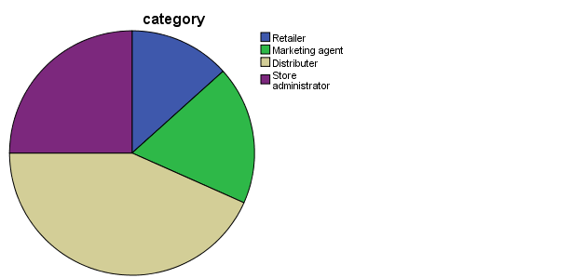

The study sought to find out the distribution of the respondents to know in which category each  
of them belonged to, in supply chain management- the respondents were asked to indicate their  
category which was either retailers (small scale wholesalers), marketing agents, distributers or store administrators. The result shows that 13.3% of the respondents were retailers (small scale wholesalers), 18.3% were Marketing agent, 43.3 were Distributers and 25% were Store administrators.

|  |  |  |  |  |  |
| --- | --- | --- | --- | --- | --- |
| **quantity_of_each_item_kept_ in_warehouse** | | | | | |
|  | | Frequency | Percent | Valid Percent | Cumulative Percent |
| Valid | Judgmental | 17 | 28.3 | 28.3 | 28.3 |
| Casual | 28 | 46.7 | 46.7 | 75.0 |
| Projective | 15 | 25.0 | 25.0 | 100.0 |
| Total | 60 | 100.0 | 100.0 |  |

1. How do you make decision on which product to stock i.e. how do you carry out demand forecasting

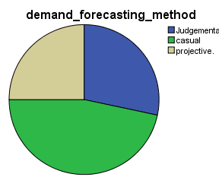

Respondents were asked to indicate how they determine the quantity of products to keep in the warehouse. Either by judgmental methods- their personal opinion, casual-depending on other factors e.g. weather, legislation or projective- using computational methods or software.

3.How do respondents identify frequent/ loyal customers.

|  |  |  |  |  |  |
| --- | --- | --- | --- | --- | --- |
| **identify_frequent/ loyal_customers** | | | | | |
|  | | Frequency | Percent | Valid Percent | Cumulative Percent |
| Valid | Personal opinion | 34 | 56.7 | 56.7 | 56.7 |
| Manually computing | 19 | 31.7 | 31.7 | 88.3 |
| Using software | 7 | 11.7 | 11.7 | 100.0 |
| Total | 60 | 100.0 | 100.0 |  |

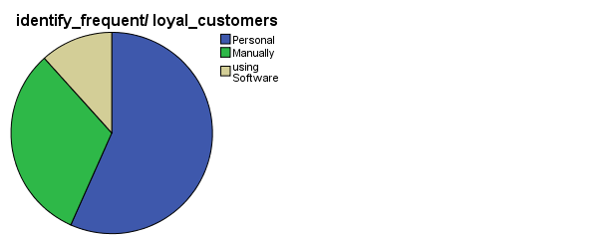

The study sought to find out the method the respondents use to determine the frequent customers. Respondents were required to indicate whether personal opinion, manually computing purchasing patterns or using software system to analyze customer buying patterns.

1. Inventory review period

|  |  |  |  |  |  |
| --- | --- | --- | --- | --- | --- |
| **inventory_review_period** | | | | | |
|  | | Frequency | Percent | Valid Percent | Cumulative Percent |
| Valid | Periodic | 23 | 38.3 | 38.3 | 38.3 |
| Continuous | 37 | 61.7 | 61.7 | 100.0 |
| Total | 60 | 100.0 | 100.0 |  |

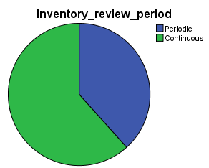

Respondents were asked to indicate how often they review their inventory They were required to indicate whether periodic review - inventory is reviewed only at fixed time intervals and a  
replenishment order is placed to bring inventory back to a predefined level or  
continuous review - there is no fixed review time or time interval, inventory is reviewed continuously

.5 How do you determine which products are bought together?

|  |  |  |  |  |  |
| --- | --- | --- | --- | --- | --- |
| **determine_products_bought_together** | | | | | |
|  | | Frequency | Percent | Valid Percent | Cumulative Percent |
| Valid | Judgmental | 45 | 75.0 | 75.0 | 75.0 |
| Projective | 15 | 25.0 | 25.0 | 100.0 |
| Total | 60 | 100.0 | 100.0 |  |

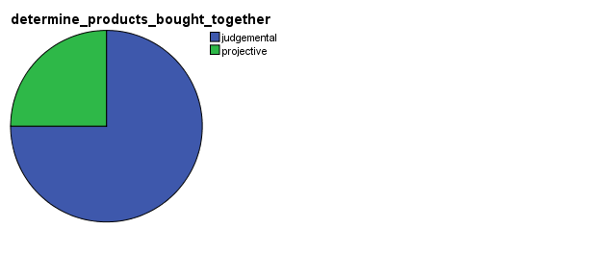Respondents were asked to indicate how they determine which products customers buy together i.e. how they determine and generate frequent itemsets. Respondents were to indicate whether they determine frequent itemsets by judgmental methods (their personal opinion), projective (using computational methods) or use software to determine customer buying behavior.

#### 4.4.2 Summary of the analysis

From the data analysis, the researcher was able to observe the following:

* Most respondents dealt with products and number of customers ranging from 0-100 and 100-500
* Most (46.7%) respondents used casual methods(depending on other factors such as weather, legislation) to determine the quantity of products to keep in the warehouse/ stores
* Most respondents (56.7%) relied on personal opinion to establish loyal/ frequent customers
* Large percent of respondents did have established inventory management system and 31.7% used book records
* On convenience of the method they use for inventory management- 5% excellent, 13.2% very good, 31.7 % good, 36.7% fair, 13.4% poor.

The researcher used the above to develop System.

# CHAPTER FIVE: INTERPRETATION OF FINDINGS

## 5.1 Introduction.

The system uses the market basket analysis; a business intelligence technique to uncover association between items which works by looking for combinations of items that occur together frequently in transactions thus assisting in predicting future purchase decisions of the customers. The technique involves analyzing large data sets for instance purchase history, to reveal product groupings as well as products that are likely to be purchased together aiding the owners on how to design their catalogue.

Market basket analysis aid in maintaining inventory- based on the inputs you can predict the future purchases of customer over a period of time. Using the intial sales data, your can predict which item which item would probably fall short and maintain stocks in optimal quality this help in improving the allocations of resources to different items of the inventory.

It increases marketing messages since the data acquired from MBA, you can suggest the next best product which a customer is likely to buy hence helping customer with fruitful suggestions instead of annoying them with marketing blasts.

## 5.2 Observations.

Results.

The minimum support and minimum confidence are set by the user and are the parameter of the FP growth algorithm for association rule generation.These parameters are used to exclude rules in the result that have a support or a confidence lower than the minimum support and minimum confidence.

After keying the minimum support to be 0.001 and the confidence to be 0.9 an output will be displayed.When the confidence is high few rules are found. The output shows the antecedent and consequent which are part of the frequent pattern algorithm. For instances the results are

* Crisps and soda are bought together
* Sugar 1kg and milk are also bought together
* Tomato 20g and cooking oil 1l are also purchased together

The output shows how the store should be laid in order to increase sales and customer satisfaction. For instance one should store crisps and soda to increase the sales. Another example is during a certain season the system can be used to look at the data in real time and find a relationship between the items for instance sugar and milk.

When the minimum support remains constant and the confidence changes to 0.2 more relationships are found and thus it is deduced that the confidence should be lower figure to come up with many relationships and thus aid the sales keeper in the store layout.

The confidence indicates the number of times the if –then statements are found true. When the confidence is 0.1 there are more relationship deduced and in order to get more rules the parameter under the rule configuration ; number of rules is set to be sixteen thus more output are produced for instance

Milo is bought frequently with sugar

Cooking oil goes hand in hand with tomato

Detergent goes together with perfume.

Milk appears on the transaction sales with sugar and thus it should be stored on the same layout in the store.

Conclusion.

Using the output retailers can determine which products are often purchased together. Retailers can optimize product placement, offer special deals and create new products to encourage further sales of these combinations thus organizing the store to increase revenue. Items that go along with each other should be placed near each other to help consumers notice them and using this data you can eliminate the guesswork while determining the optimal store layout.

Based on the insights from Market basket analysis the output can aid in content placement in case of e-commerce business ,website content placement is very important since goods are displayed in right order thus can help boost sales.

Market basket analysis helps in studying customers buying patterns and preferences to predict what they prefer to purchase along with existing items in the cart.

### 5.3 System Design

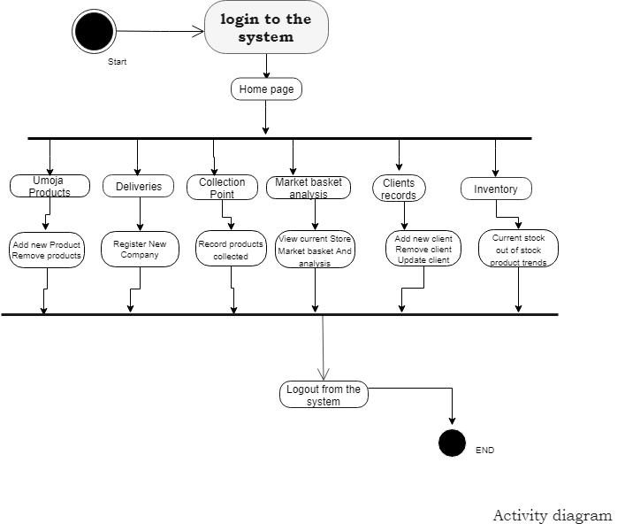

Figure 3: Activity diagram.

The activity diagram shows the activities that will be carried out by the administrator when he logins in to the homepage. The admin will check the products out of stock and also can view the analysis in which there is the most frequent items bought. The administrator can also register new companies and also new clients into the system. Once a delivery is made the administrator feeds in the data and thus inventory is brought back to their levels.

Contexual Diagram.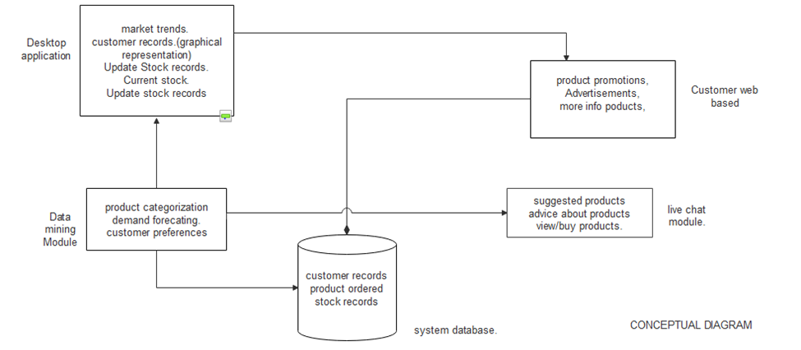Figure 4: Contexual Diagram

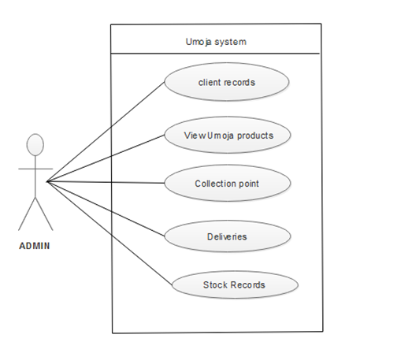

Figure 5: Use Case

Use case are a starting point for test design. The use case describes how the user check, adds, modifies or removes items in the company inventory. The administrator can view the available stock records, deliveries, and all the client records. It is used to gather the requirements of a system including internal and external influences. There is only one user to use the system. It shows what the system will basically do and what it will entail such as client records which are basically the customers records.

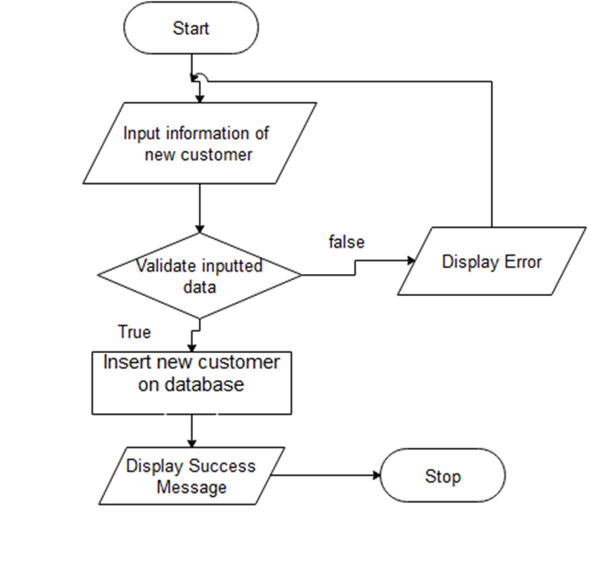

Figure 6 : Admin flow Chart

It is a graphical representation of the data. It identifies the path the data will take, what process will take place to it from one another .Data flow diagram this is whereby the administrator activities are well listed out.

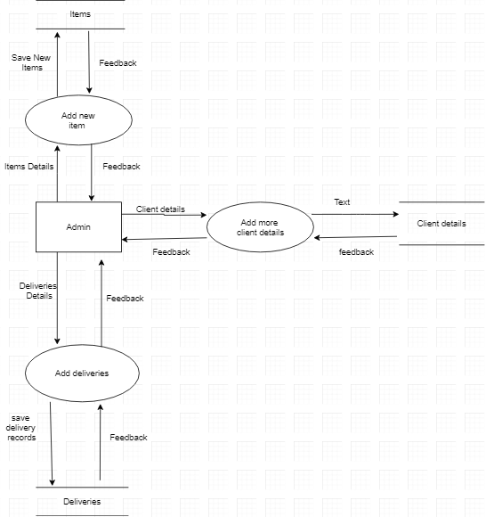

Figure 7: Data flow diagram.

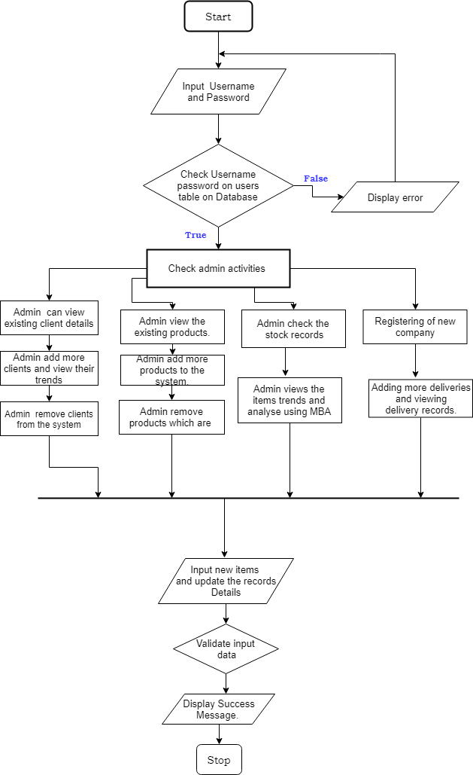

Figure 8: Flowchart

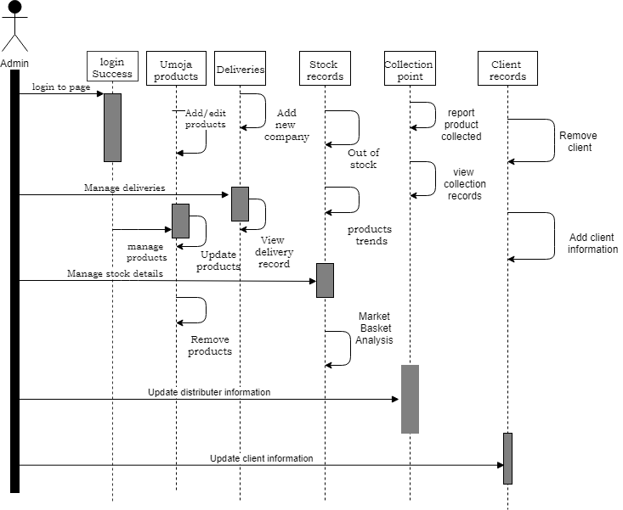

Figure 9: Sequence Diagram

This is the login sequence diagram of inventory management system which admin will be able to login to their account using their credentials. After login administrator can manage all the operations on delivery, supplier and also update the clients details in the system.

## 5.4 TESTING THE PROTOTYPE

Administrator Home Page.

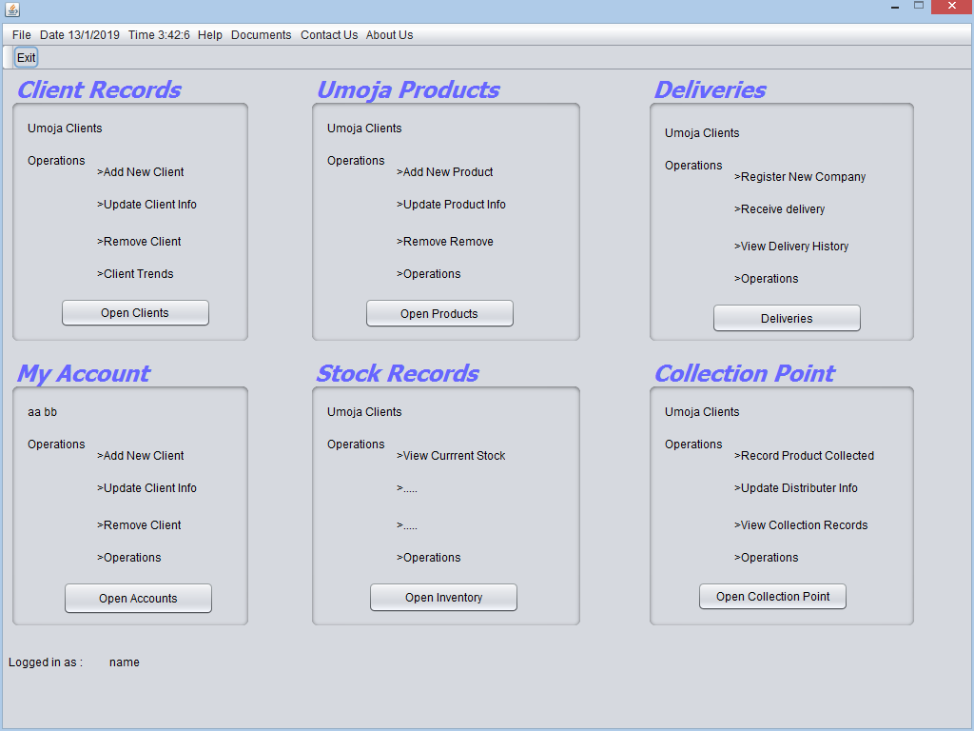Upon login, home page starts up. It contains links to client record, umoja products,deliveries, stock record, collection point and user account.

### 5.5:Stocks Records

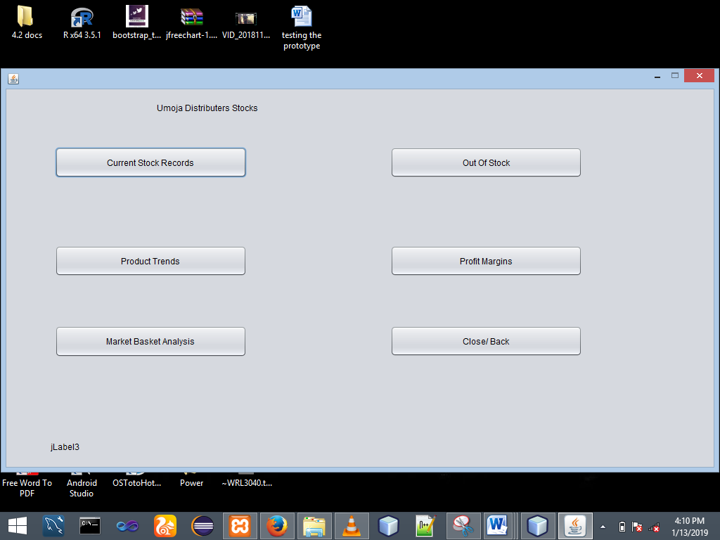

View Current Stock.

All products are listed alphabetically alongside with the available quantity in table format.

Stock chart contains a bar graph comparing quantity of products in stock. The products can also be compared in terms of total cost i.e. price of each product * available quantity. More information about the product can be displayed by clicking on the product in the table.

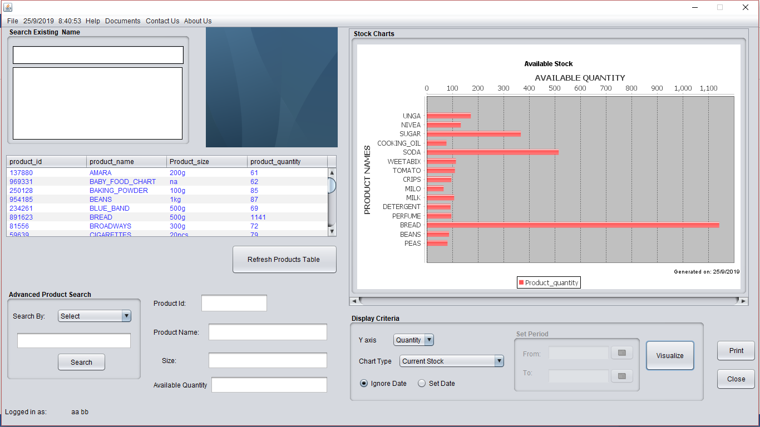

Market basket analysis**.**

The first step involves loading the dataset to the Umoja Expert System.

The dataset can also be loaded from arff file.

The user then configures the rule. This involves: setting the number of rules to output; selecting whether to save the output as excel file- setting the output name and the directory which the file will be saved.

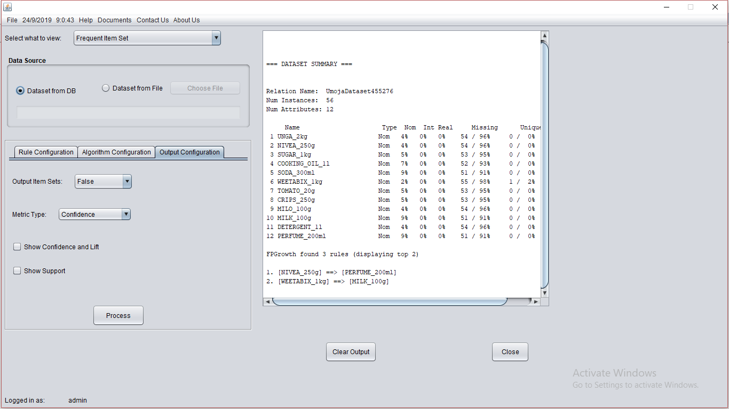

The user can load the dataset from arff file in order to test more frequent items found.

Algorithm configuration

Involves setting the algorithm to be used, minimum support, confidence, products to be included in the rules.

Output Configuration

The user sets what should be included in the output

This includes lift, confidence, both or just rules

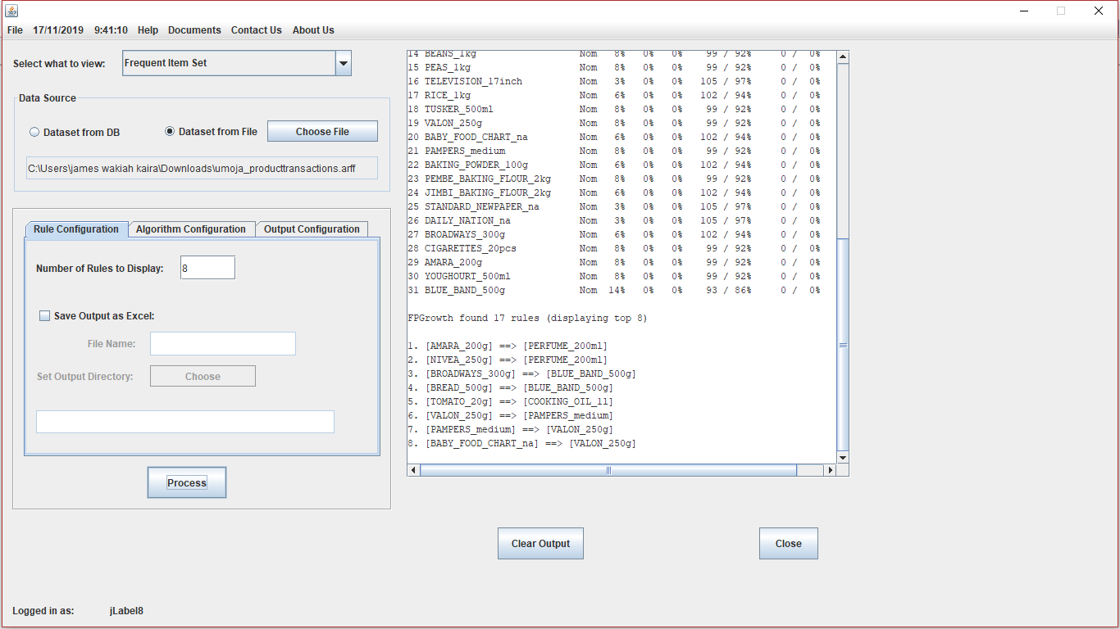

Client Records.

Contains features such as view clients, add new client, remove a client and view client trends

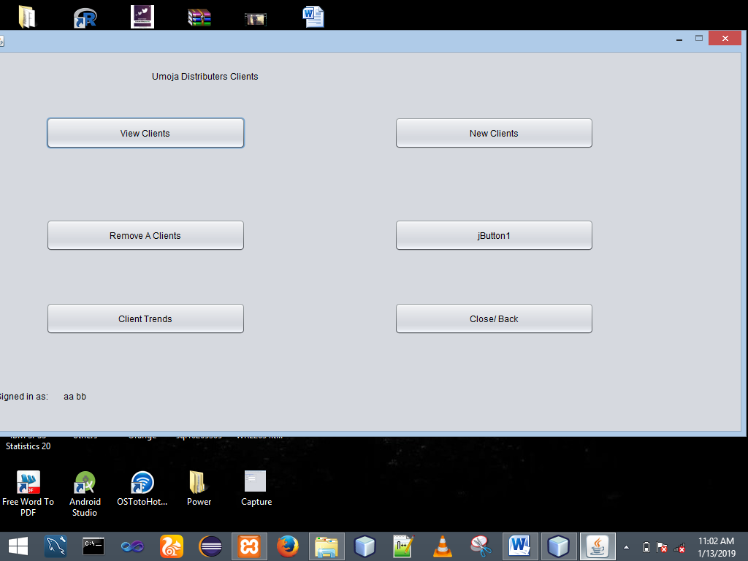

### 5.6:Umoja products.

Product home page contains links to add new product, view products, remove a product and back to home page

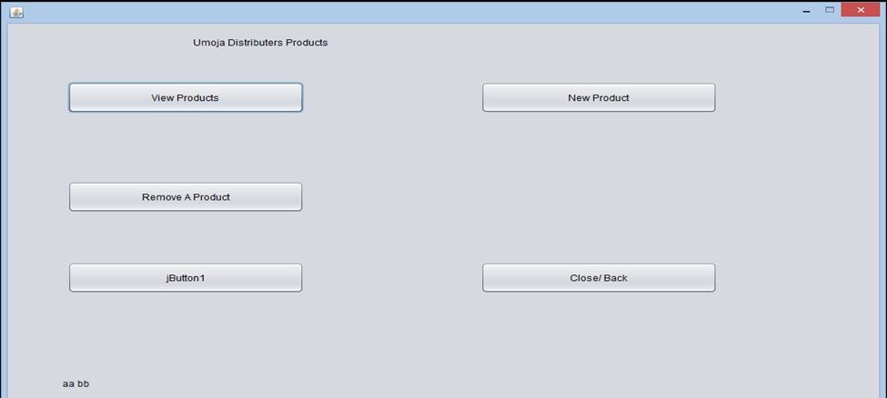

Registering new product.

While testing the prototype, the product details used are:

Product name- soda; size- 300ml;

Buying price, wholesale selling price, retail selling price, minimum quantity (used to alert when product is about to get out of stock)

On clicking save, user is required to verify the product details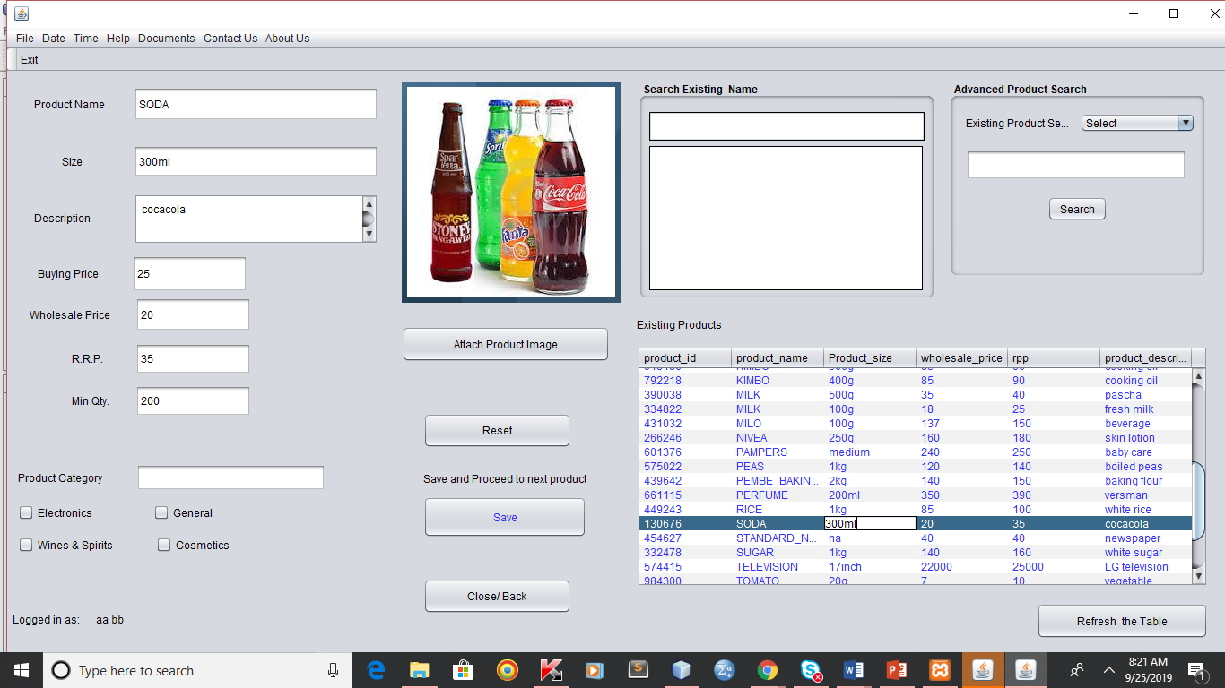

View Products.

User can view the products which are in the database.

The user can search for a specific product either by product name, product id or scroll the products table which lists products names alphabetically

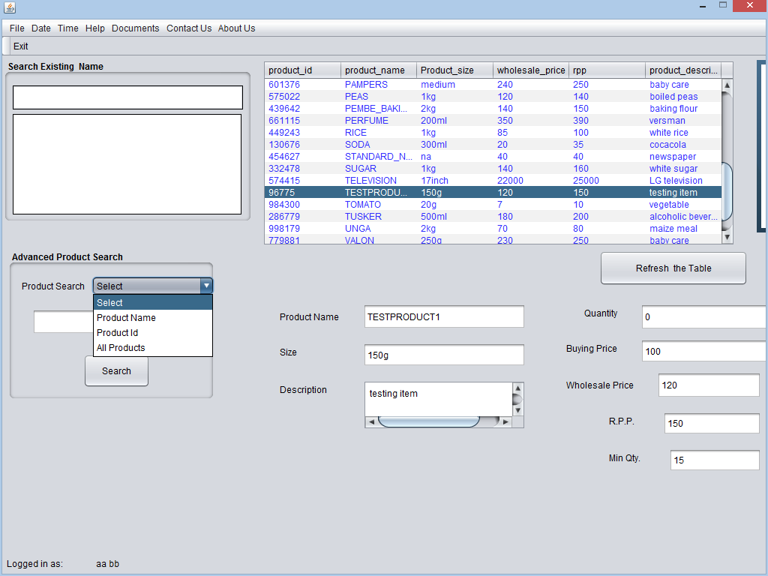

Remove Products.

User can delete product records. User is prompted to confirm details of the product to be deleted

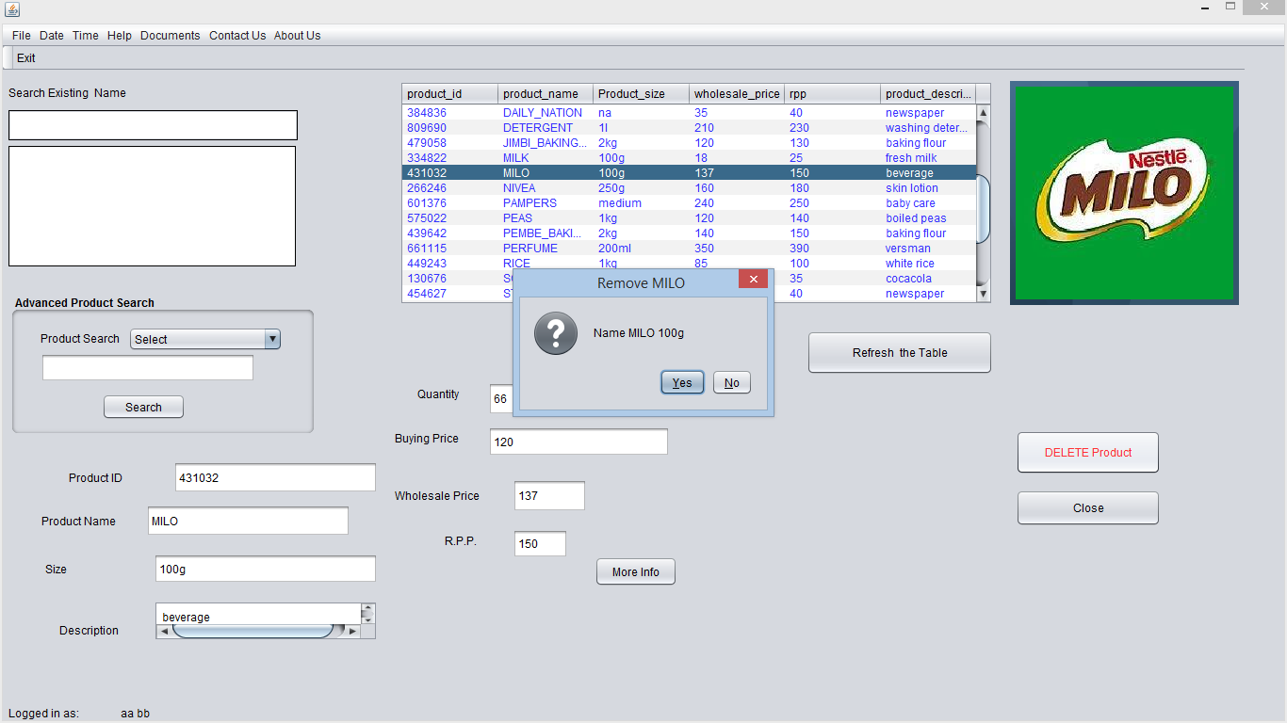

### 5.7: collection point home*.*

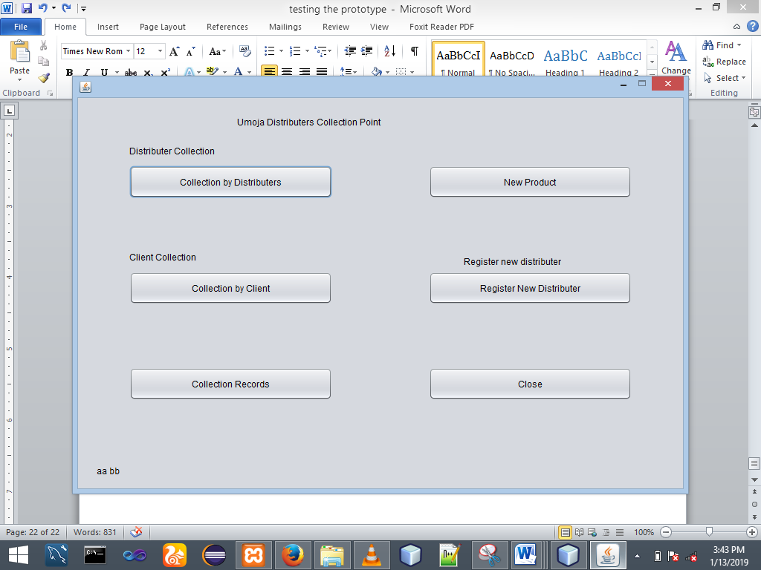

collection point home page.

Collection by distributer.

The first step involves selecting the distributer; user can search for the distributer or scroll distributers table which contains all distributers names ordered alphabetically

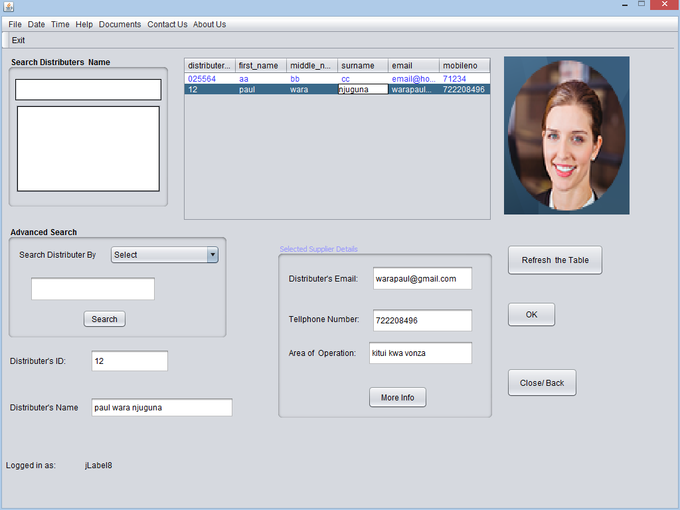 selecting distributer at collection point

Collection by client is similar to that of distributers

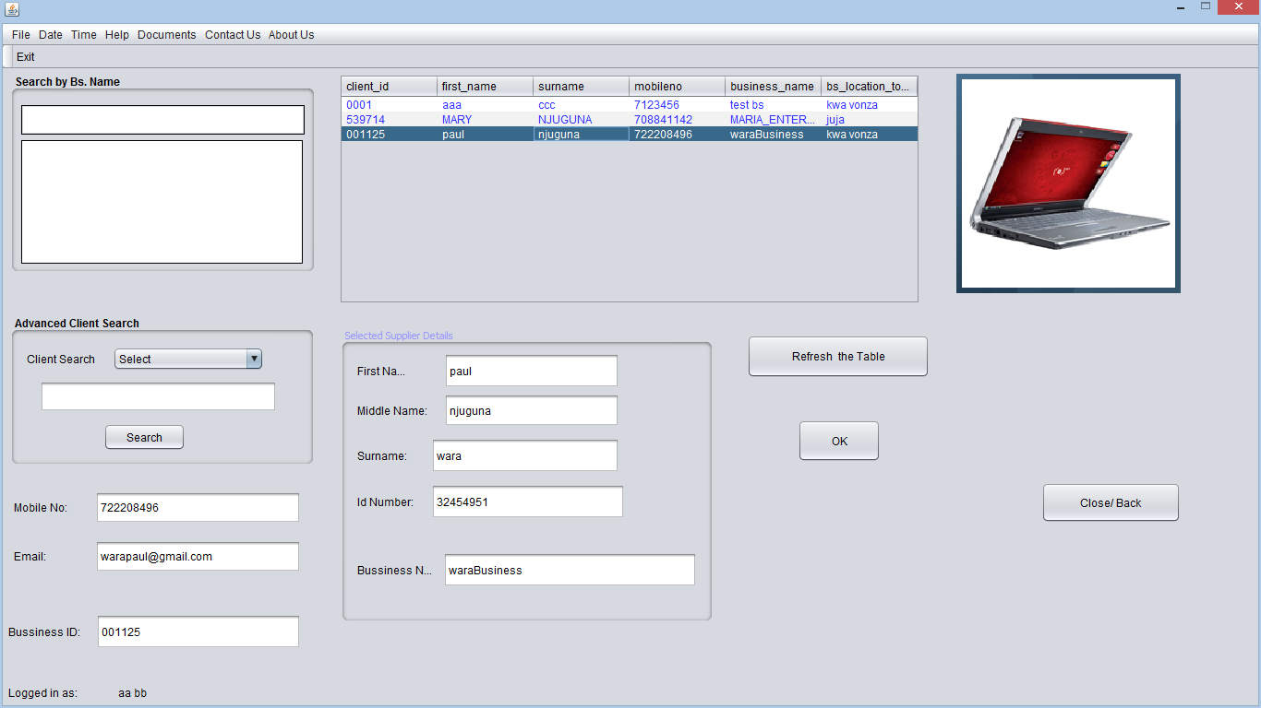

selecting client at collection point

After selecting the client or distributer, the collection page loads. It has details of the customer or distributer i.e., id, name, email. Also all products are listed alphabetically. The user can search for a product. When a product is selected the user edits the quantity of products purchased from the default value of one then adds to cart.

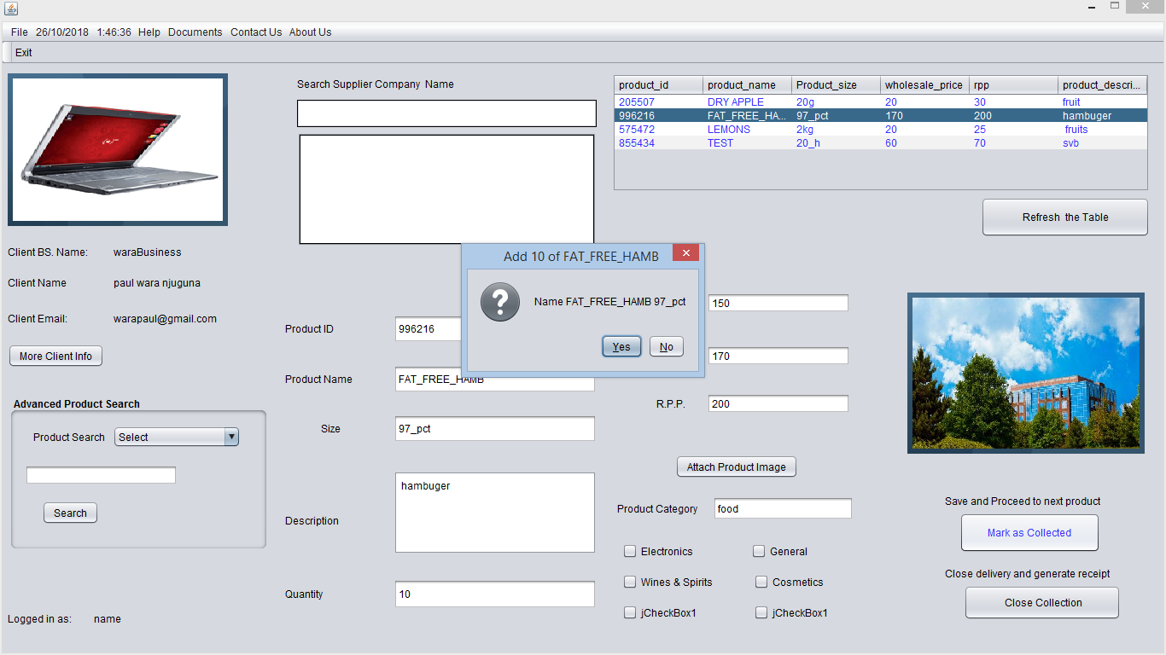

product collection by customers

After all required products have been collected the user closes the collection

A summary of the collected product will be produced in order to print receipts

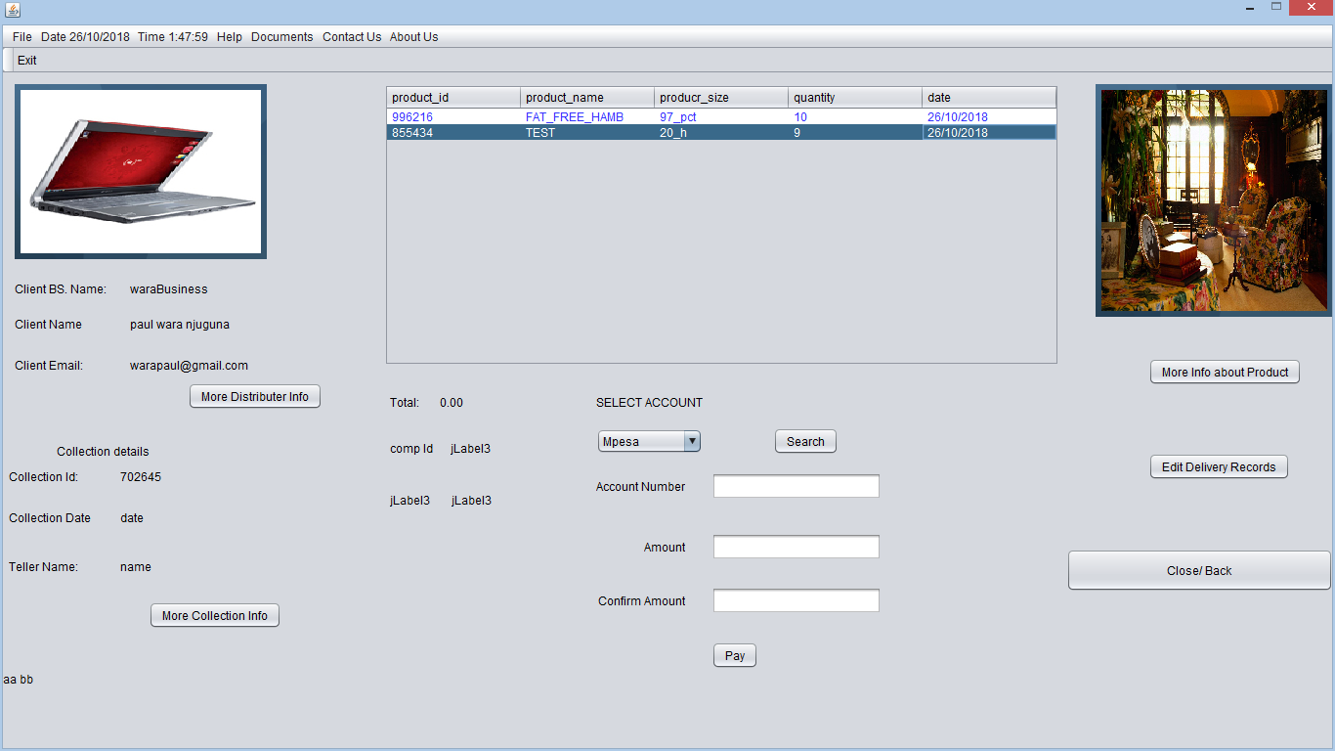

summary of collected products

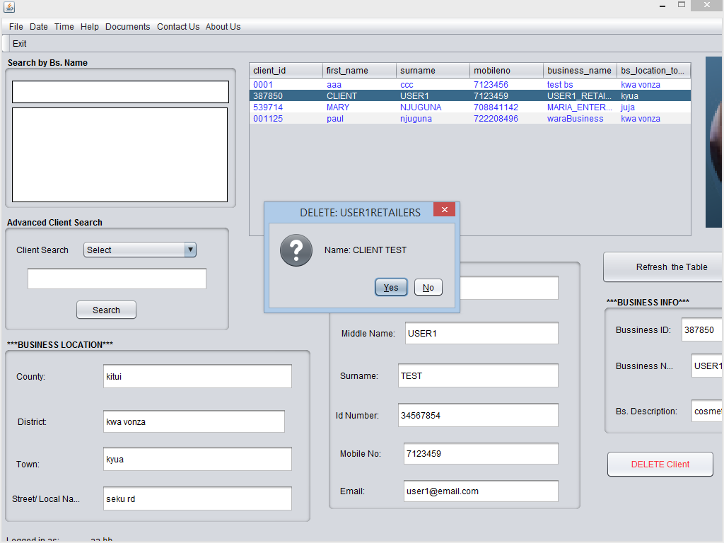

confirm the client to be deleted

View Client Trends.

Client trends can be viewed in terms of

1. Frequency which they purchase

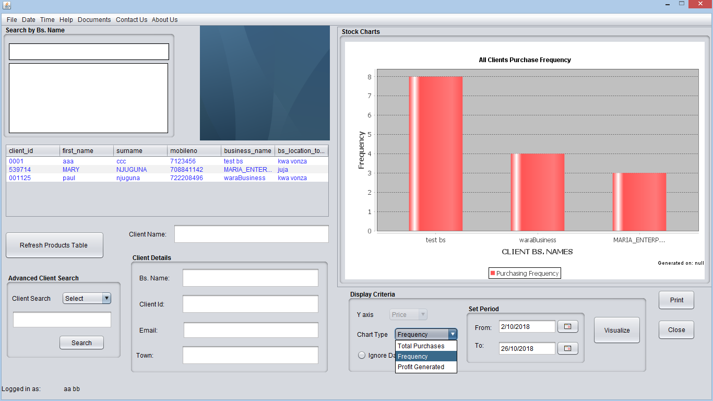

Client trends- purchasing frequency

1. Total purchases

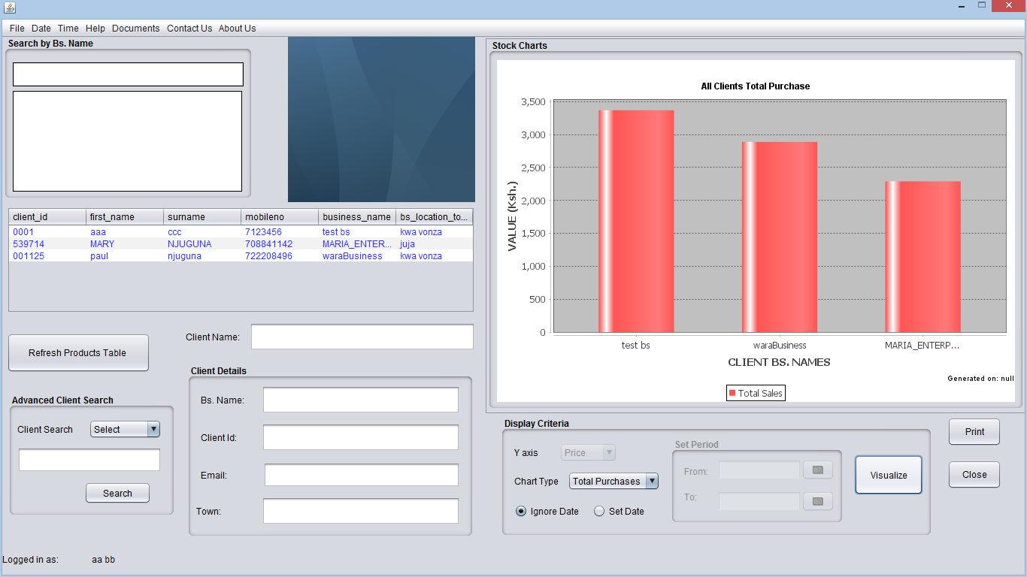

Client trends-total purchases

b.profit generated from the clients

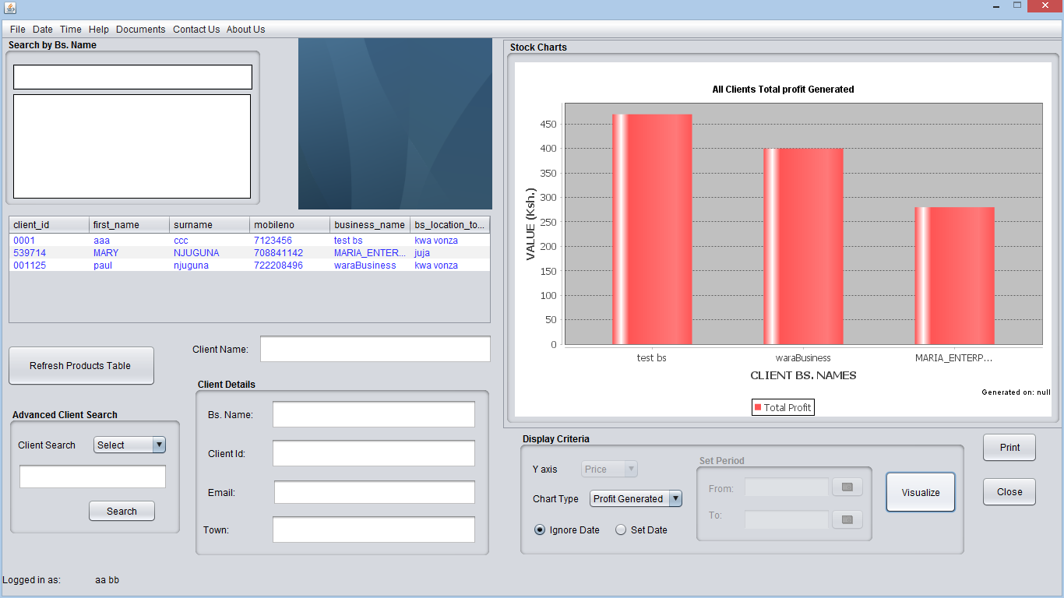

### 5.8:Product Trends.

Product sales and purchases are presented in terms of quantity or price.

#### Product purchase

Displays a line chart showing either quantity or price of product bought against date. Setting date will limit purchase date between the period selected

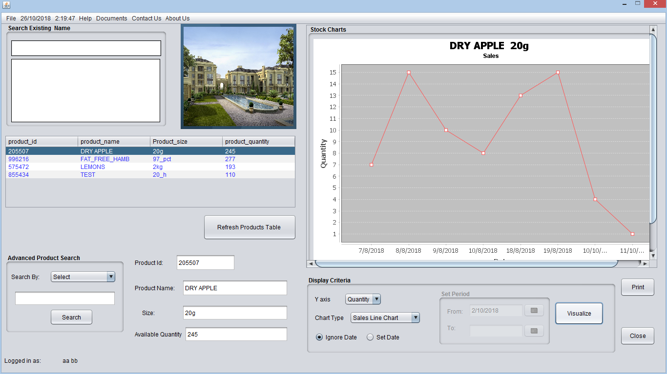

Purchase trend

#### Product sales

Display line chart showing sales (Quantity or cost) of a particular product over a period of time



sales trend

#### Product purchases vs sales

Compares purchases of a specific product to its sales over the set period of time

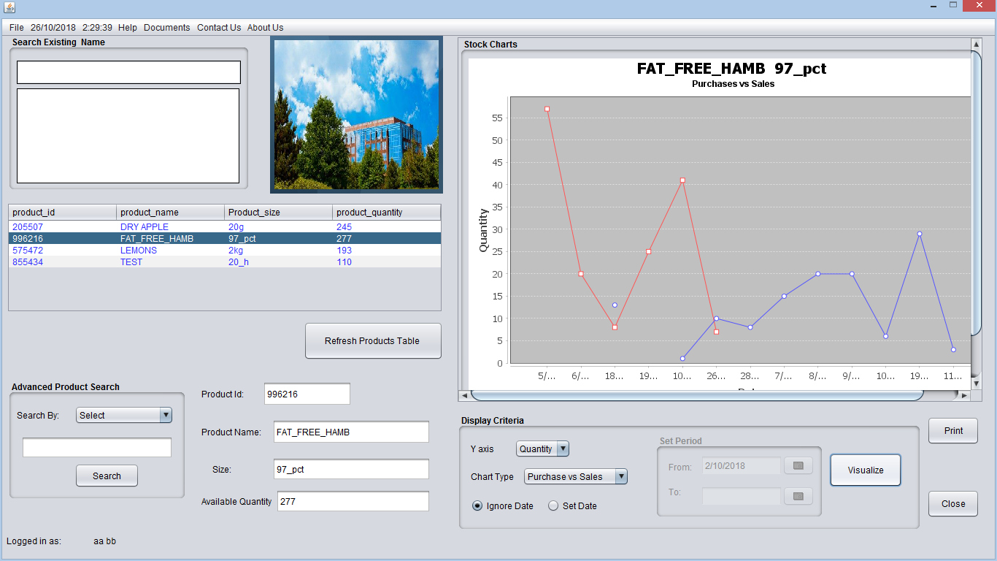

product purchases vs sales trend

### 5.9: Deliveries

When suppliers and manufacturers bring products to Umoja warehouses, they are recorded under deliveries.

It involves adding new supplier, recording new delivery, viewing delivery records.

Incase the supplier introduces a new product the administrator can add the new product under the deliveries.

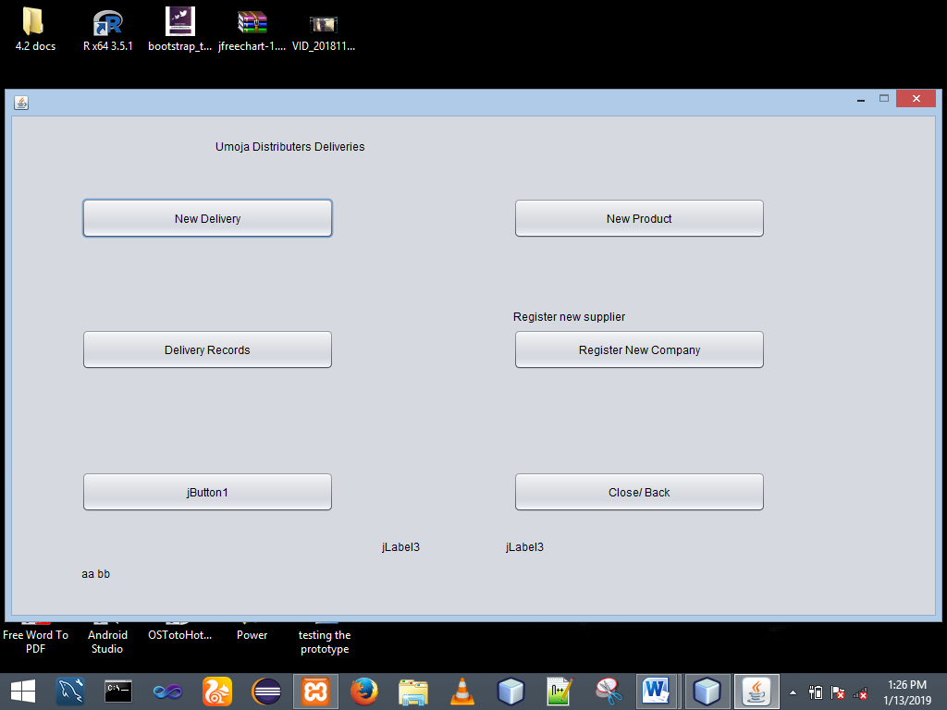

Registering new supplier.

Required details include: supplier company name; contact details- mobile number, email, postal address, web address; company location details- County, district, town and street names; supplier image; product categories

NB fields in blue must be filled

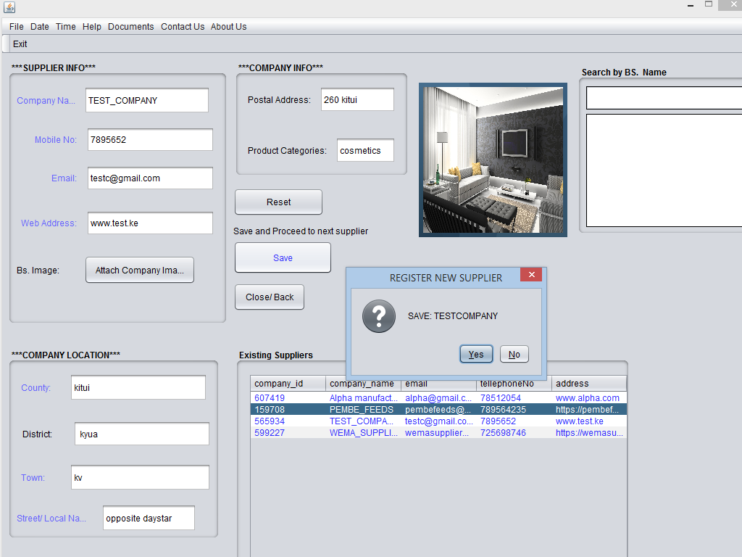

New Delivery

The first step involves selecting a supplier

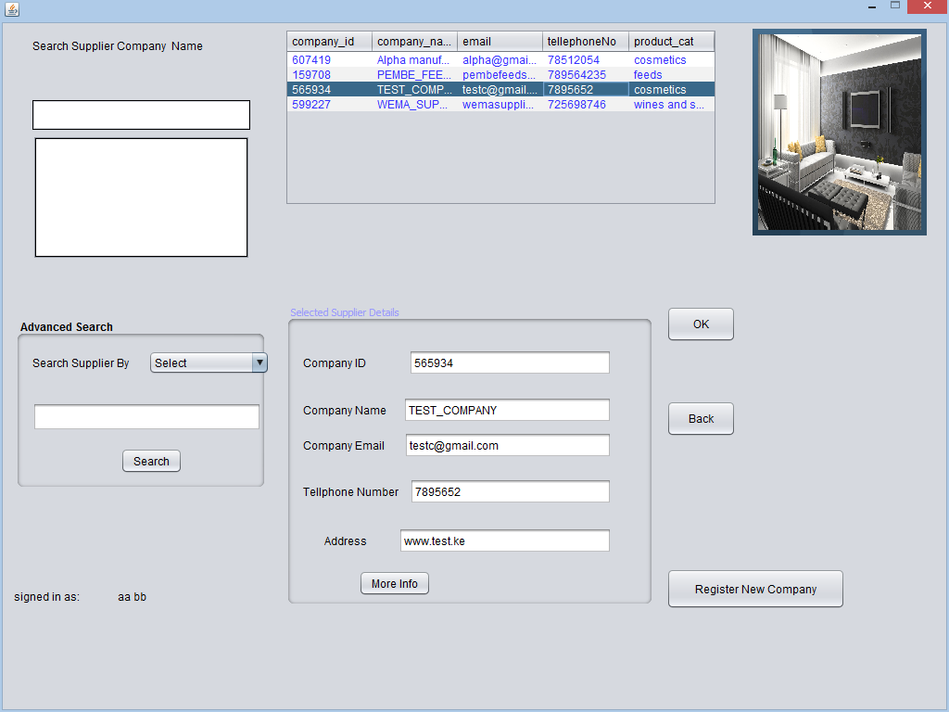

New delivery- select supplier

The record each product delivered. This involves selecting the product from products table or searching for the product by product name, product id.

Upon selecting the product from the table, the text fields for product details are automatically filled.

The user is required to edit the field for product quantity whose default value is 1. The user sets the quantity delivered and verifies the details before saving

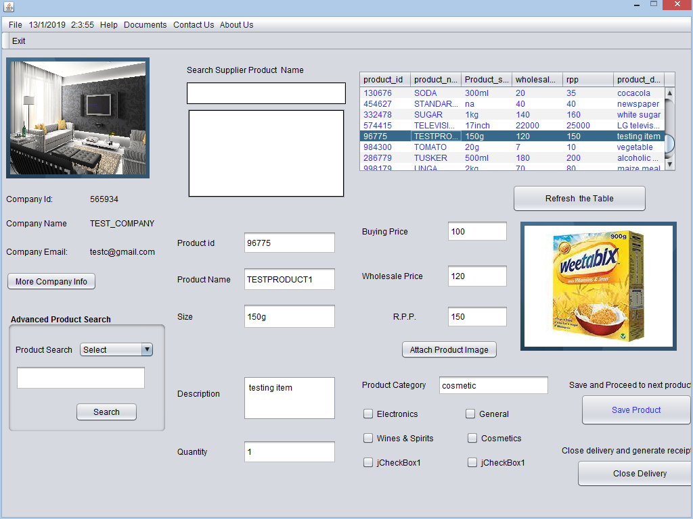

New delivery- add products

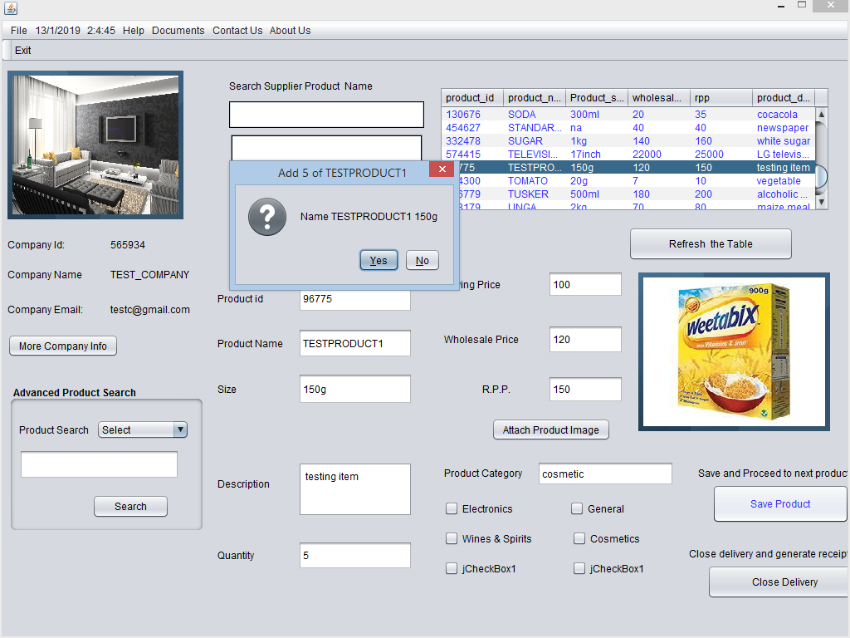

New delivery- confirm product

If the product has been successfully added to the cart the user is notified

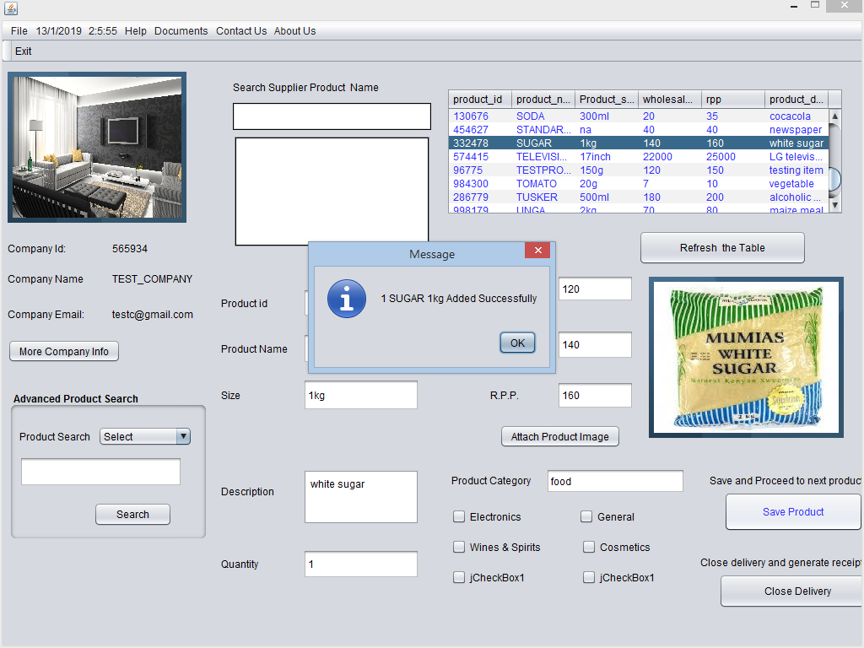

delivery- product added successfully

After all products delivered by company X have been recorded, the user is supposed to close the delivery and a receipt will be produced. It contains the supplier details, all products delivered and more details about the product can be viewed by clicking on the product.

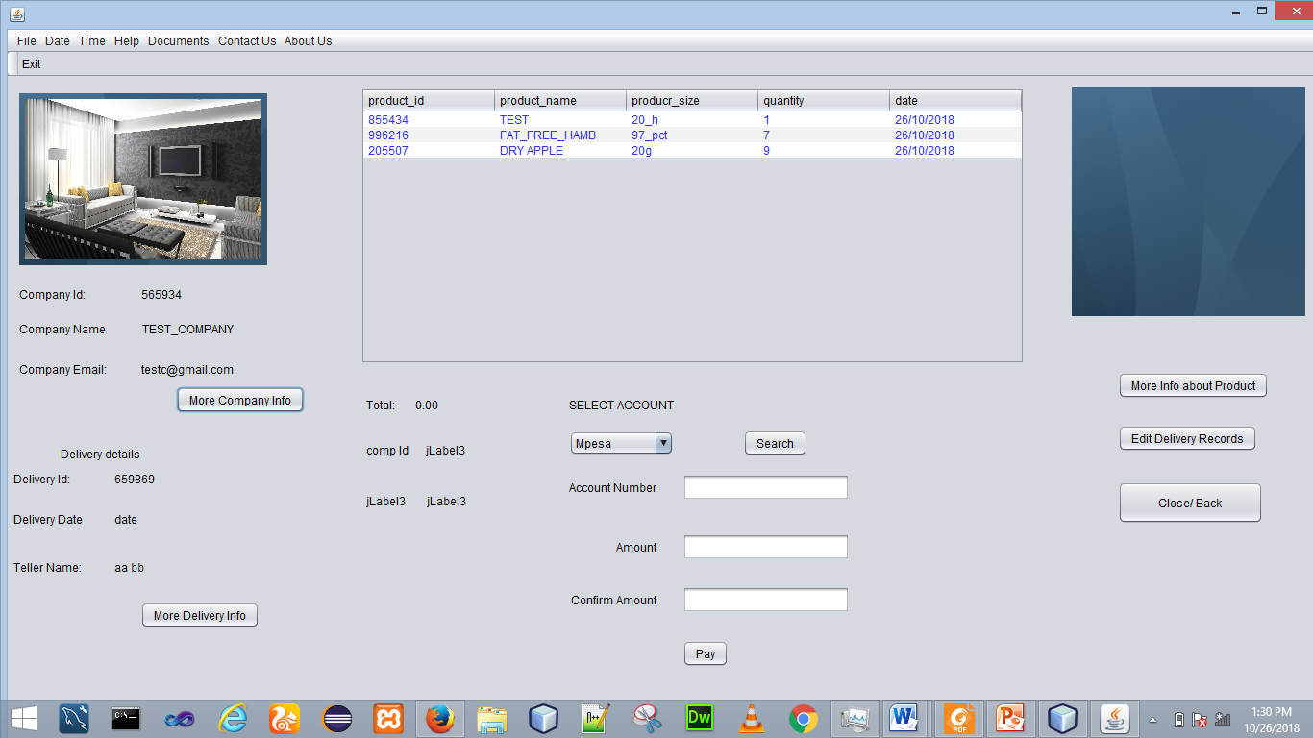

delivery summary

Delivery Records.

The user of Umoja Expert Distributer System can view delivery records that have accumulated over a period of time for a specific supplier company.

All companies that have supplied to Umoja distributers are listed order by delivery date.

On clicking a specific a deliver item i.e. on suppliers table, all products delivered under that supply id will be displayed in delivered products table. Supplier’s details will be displayed.

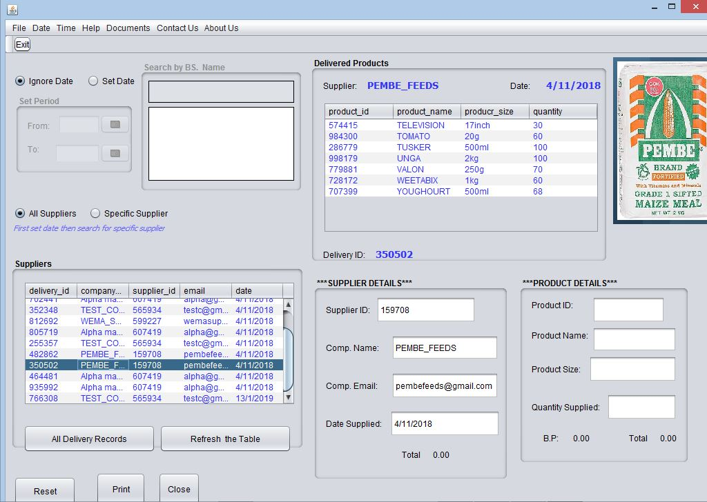

delivery records

More information about the product will be displayed when the product in delivered products table is clicked

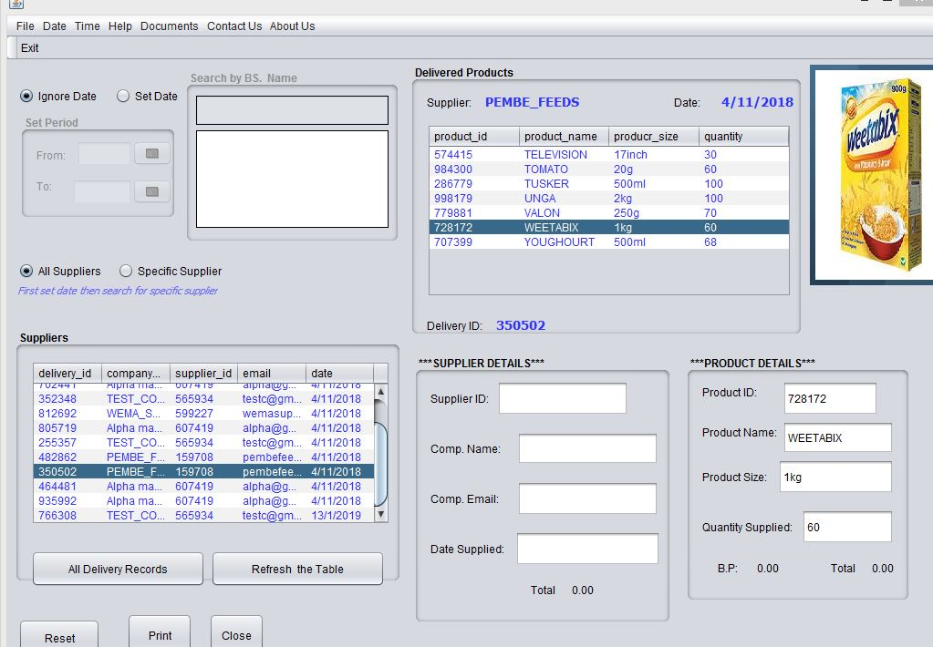

more product info

To display delivery records by a specific supplier:

Select the radio button at top left part of the page for ‘specific supplier’ the search the supplier by business name i.e. company name

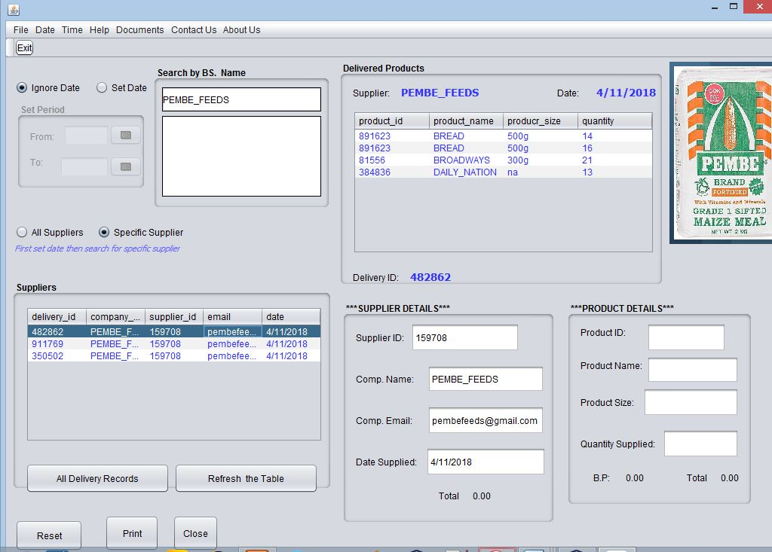

records for a specific supplier

The user can also view deliveries made within a specific period of time by selecting the radio button for set date and setting the period for which records should be displayed

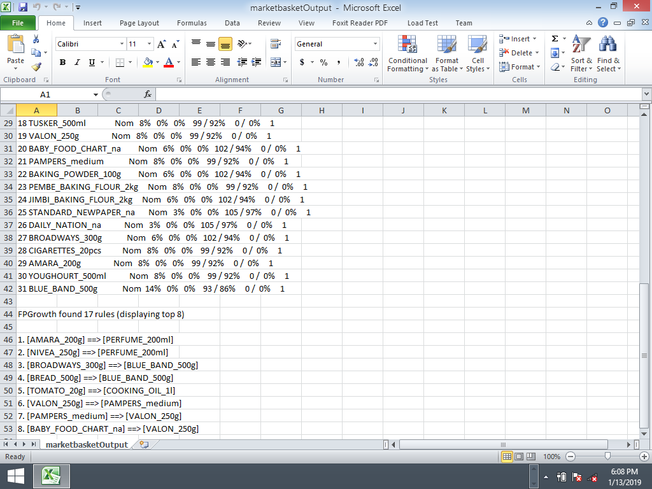

Output file saved in excel

**Sample Databases**

**Products DB**

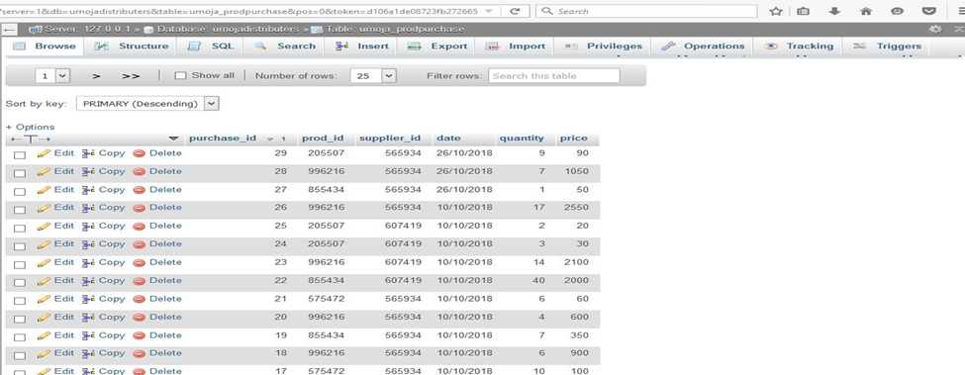

# CHAPTER SIX

## SUMARRY, CONCLUSION AND RECOMMENDATION

### 6.1 Introduction

This chapter summarizes the finding of the study and makes conclusions upon which  
recommendations are drawn. Suggestions for further study are also captured as a way of filling  
the gaps identified in the study. The chapter also summarizes the findings of the current method  
of the system and whether to adopt the Umoja Expert Distributer System.

### 6.2 Summary of Findings.

This research project aimed at helping distributers and wholesalers in dealing with supply chain management issues such as storing and generating transaction records, determining products to stock and establishing loyal customers.

The researcher viewed previous studies with a view of establishing academic gaps which present study sought to bridge. This was mainly done through online journals review. The procedure included: reading, evaluating the methodology employed in terms of  
design choice, target population, sample and sampling procedure data collection instruments  
(that is suitability, validity and reliability), data collection procedures, data analysis, findings and  
recommendations. The study benefited so much from the literature review for it guided the  
present study by pointing to areas that need to be investigated

The study employed quantitative research as the main approach to guide the study. The target  
population included 60 respondents from Nyeri Town. Data was collected using questionnaires.  
Data analysis was started immediately on the field. Data was summarized into frequencies and  
percentages, then later presented in bar charts and tables. Though there might have been  
deficiencies in the tools used, the researcher made sure to make them as minimal as possible.

### 6.3 Conclusion.

The outcome of this research project is very beneficial to personnel involved in supply chain management i.e. wholesalers/ distributers, marketing agents and store administrators. This system is convenient compared to using books of records in supply chain. It also has some additional features compared to most of the current inventory system being used e.g. capability to analyze customer purchasing patterns to determine customer preferences and establish frequent item sets.

An important assumption made while developing the system was that target users have basic computer skills and are familiar with the English language.

### 6.4 Recommendations.

The Umoja expert Distributer System was made from scratch and is open for further  
development and improvements.

Other important modules should be developed to assist in supply chain management in terms of demand forecasting, customer data analysis and inventory management.

The researcher therefor recommends that supply chain managers to take advantage of this system which eliminates errors involved in manual supply chain management and has capabilities to discover hidden patterns in transactions data.

### 6.5 Suggestions of Further Studies.

Due to resource and time constraints, my study could not address all issues that may have been  
pertinent. Therefore, further research should be done on how we can develop web based or mobile application that customers can use to interact with the system in order to be advised on complementary or supplementary products. Also how on how to incorporate the system functionality on hand held devices mainly in recording transactions and managing customers, products and suppliers.

# CHAPTER SEVEN

## APPENDICES AND REFERENCES

### 7.1: Design Tools

For development of the desktop application NetBeans will be used. Java Swig components shall be used for development of the interface for the desktop application.

The database will be designed using MySQL since it’s an open source application. Also, Xampp database will be used.

### 7.2: Appendices

## Appendix A: Project Schedule

|  |  |  |
| --- | --- | --- |
| TASK | DURATION | DELIVERABLES |
| Problem definition and Literature review | 2 weeks | Identify the problems and the scope of the system. |
| Requirements Gathering | 4 weeks | Arrange a study to gather information and learn the problem domain. |
| Project Design and Analysis | 5 weeks | Map up the project in terms of how the end system will be |
| Project Coding | 3 weeks |  |
| Integration and Testing | 2 weeks |  |
| Documentation | One week |  |
| Implementation | 2 weeks | Developing the system. |
| Project Review and testing | One week. | Test the system to know whether it’s functioning well. |

Table 1: Project Schedule.

### Appendix B: Project Budget Estimates

|  |  |
| --- | --- |
| ITEM | ESTIMATED COST(KSh.) |
| Computer | 40,000 |
| Research/ Data collection | 10,000 |
| Hosting | 3,000 |
| Softwares (NetBeans, phpMyAdmin) | 5000 |
| Typing, printing and binding | 6,000 |
| Transport | 5000 |
| Internet connection | 5000 |
| Accommodation | 3000 |
| Total | 77,000 |

Table 2: Budget estimates.

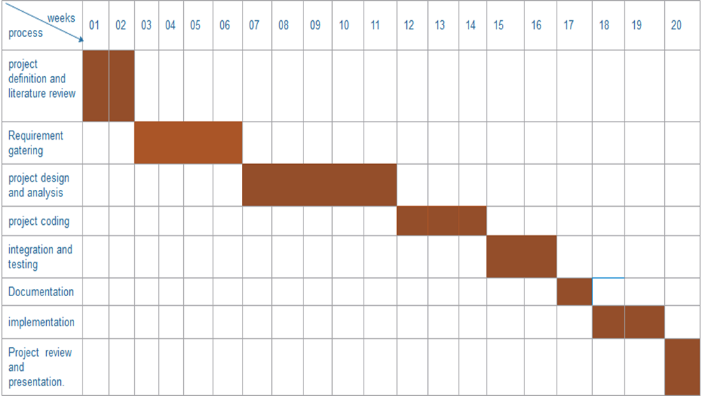

Table 3: Gantt chart

### Appendix C: Software Requirements

|  |  |
| --- | --- |
| Software | Minimum System requirement |
| Operating System | Windows 10 or later |
| Run-time Environment | NetBeans, eclipse with jdk and sdk, ionic, sql |
| Programming languages | Java, |

Table 4: Software Requirements

### Appendix D: Hardware Requirements

|  |  |
| --- | --- |
| Hardware | Minimum System requirement |
| Processor | 2.4 GHZ processor speed |
| Memory | 512 MB RAM (2GB Recommended) |
| Disk space | 90 GB (including 20 GB for Database Management system) |
| Display | 800 x 600 colors (1024 x 768 High color- 16 bit Recommended) |

Table 5: Hardware Requirements

### References.

Leonard Murphy. (2015, June 26). *Challenges facing market research industry* [Online]. Available: <http://www.greenbookblog.org>

USAID (2011). The Logistics Handbook: A Practical Guide for the Supply Chain Management of Health Commodities. Published by The U.S. Agency for International Development. Available from: http://apps.who.int/medicinedocs/documents/s20211en/s20211en.pdf

Barcodes Inc (2010) what is Inventory Management, [online]. Available at: <http://www.barcodeinc.com/article/what-is-inventory-management.html> [Online]

Ferencikova, D. (2014). Inventory Management in Small and Medium-Sized Manufacturing  
Companies and Its Main Dilemmas*. Proceedings of the 2014 International Conference on Industrial Engineering and Operations Management* (pp. 756-762).

Rushton, A., Croucher, P. & Baker, P. (2011). The Handbook of Logistics & Distribution  
Management.

Othman, N. N. (2015). *A Study on Inventory Management at A Manufacturing Company*. Degree's Thesis, University Malaysia Pahang, Faculty of Industrial Management.

Dube, L. & Pare, G., 2003. Rigor in Information Systems Positivist Case Research:   
Current Practices, Trends, and Recommendations. MIS Quarterly, 27(4), pp.597–635. Available at: <http://www.jstor.org/stable/30036550>. Edv-buchversand.de. (2017). [online] Available at: http://www.edvbuchversand.de/chapter.php?cnt=getchapter&id=gp-108.pdf [Online].

Boter, R. and L. Fortuin. 2000. Stocking strategy for service parts: A case study. *International  
Journal of Operations and Production Management* 20 (6):656-674

O’Brien, J. (2009). Category management in purchasing: a strategic approach to maximize business profitability, Kogan Page.

Muller, M. (2011). Essentials of Inventory Management Second Edi., AMACOM.

Harris, F.W. (1913). How Many Parts to Make at Once, Factory. The Magazine of Management, 10(2): 135-136, 152.

Roy, T.K., and Maiti, M. (1997). A Fuzzy EOQ Model with Demand Dependent Unit Cost under  
Limited Storage Capacity. European Journal of Operational Research, 99: 425-432

Coyle, John J. Bardi, Edward J. Langley C. John Jr. 2003. The Management of Business  
Logistics: A Supply Chain Perspective. 7th edition. South-Western Thomson Learning

Christopher, M. (1998). *Logistics and Supply Chain Management*. London: Pitman..

Bolton, Ruth N., Dhruv Grewal and Michael Levy (2007), “Six Strategies for Competing Through Service: An Agenda for Future Research,” *Journal of Retailing,* 83 (1), 1–4 Kumar, V. and Denish Shah (2004), “Building and Sustaining *Profitable* Customer Loyalty for the 21st Century,” *Journal of Retailing,* 80 (4), 317–30

Park, K.S. (1987). Fuzzy-Set Teoretic Interpretation of Economic Order Quantity. IEEE *Trans. System, Man, Cybernetics,* SMC-17: 1082-1084

Yao, J.S., Chang, S.C., and Su, J.S. (2000). Fuzzy Inventory without Backorder for Fuzzy Order Quantity and Fuzzy Total Demand Quantity. *Comput. Oper. Res*., 27: 935-962

Chang, H.C. (2004). An Application of Fuzzy Sets Teory to the EOQ Model with Imperfect Quality Items. *Comput. Oper. Res.,* 31(12): 2079–2092.

Lam, S.M., and Wong, D.S. (1996). A Fuzzy Mathematical Model for Joint Economic Lot Size Problem with Multiple Price Breaks. *European Journal of Operational Research*, 95(3): 611–622